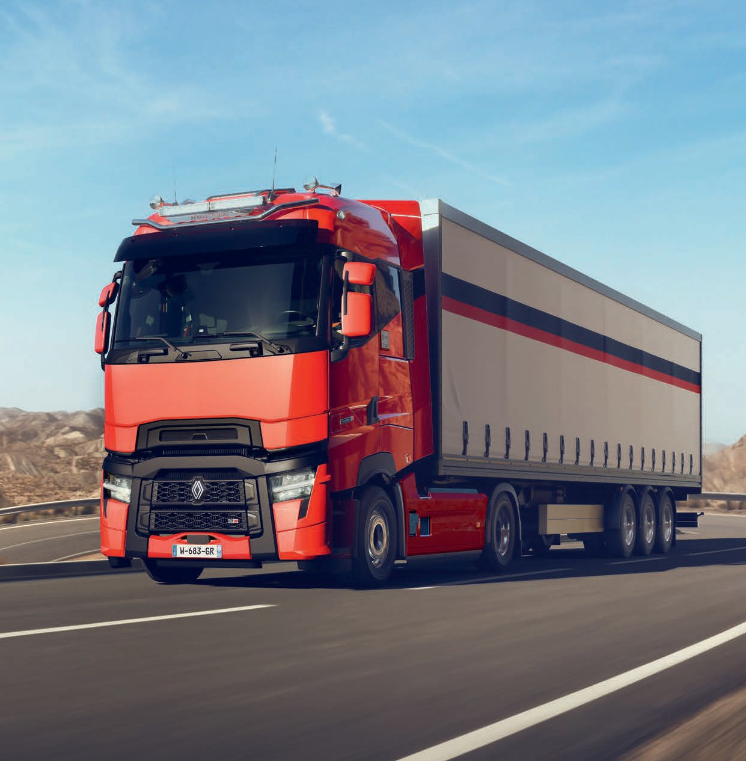






Long Haul
RENAULT TRUCKS T / T HIGH

renault-trucks.co.uk

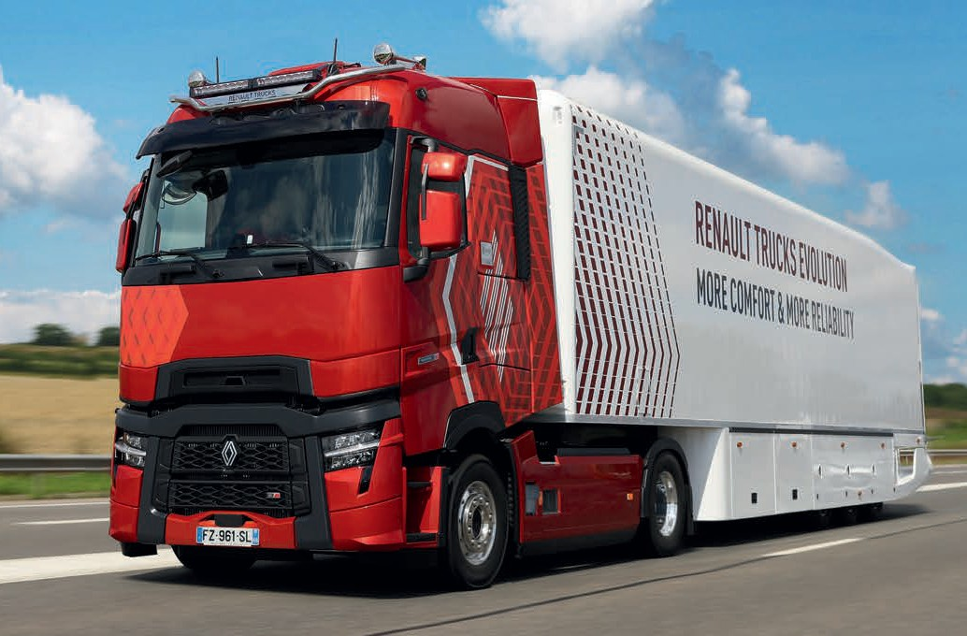

TAKE THE ROAD WITH
RENAULT TRUCKS 03
5 GOOD REASONS TO CHOOSE
RENAULT TRUCKS 04
AN EXTENSIVE SERVICE HELPING YOU
TO OPTIMISE YOUR PRODUCTIVITY 06
EXPERTS AT YOUR SIDE, AT YOUR SERVICE 08
DRIVE WITH COMPLETE PEACE OF MIND 10
SIMPLE AND EFFICIENT VEHICLES
HELP CONTROL YOUR COSTS 12
A DRIVELINE DESIGNED FOR FUEL
ECONOMY 14
TECHNOLOGY FOR CONTROLLING
YOUR COSTS 16
AERODYNAMIC DESIGN 18
ALL-IN-ONE FINANCING 19
A NEW, OPTIMISED INTERIOR
PROMOTING DRIVER WELL BEING 20
OUTSTANDING DRIVING COMFORT 22
A LIVING AREA JUST LIKE HOME 24
PERSONALISE YOUR TRUCK 26
ACCESSORIES FOR EVEN MORE COMFORT 28
TECHNOLOGY SERVING SECURITY 30
SAFETY EQUIPMENT TO SUPPORT YOU 32
TO FIND OUT MORE... 34
RANGE POSTER 36
DRIVELINE 37
CABS 38
CHASSIS 39
CONTRACTS 40

Take the road with Renault Trucks

Driving with Renault Trucks means choosing a local partner committed to meeting your support whenever you need it.
It means being supported in your energy transition, to meet the challenges of a more sustainable mobility solution.
It means choosing the best technical and financial solutions that a global group has to offer.
It means choosing vehicles that are functional, efficient and comfortable, for an extended use.
It means choosing proven, easy-to-use technology and services adapted to your requirements.
It means forging a strong, welcoming and dependable working relationship.
It means making the right choice.
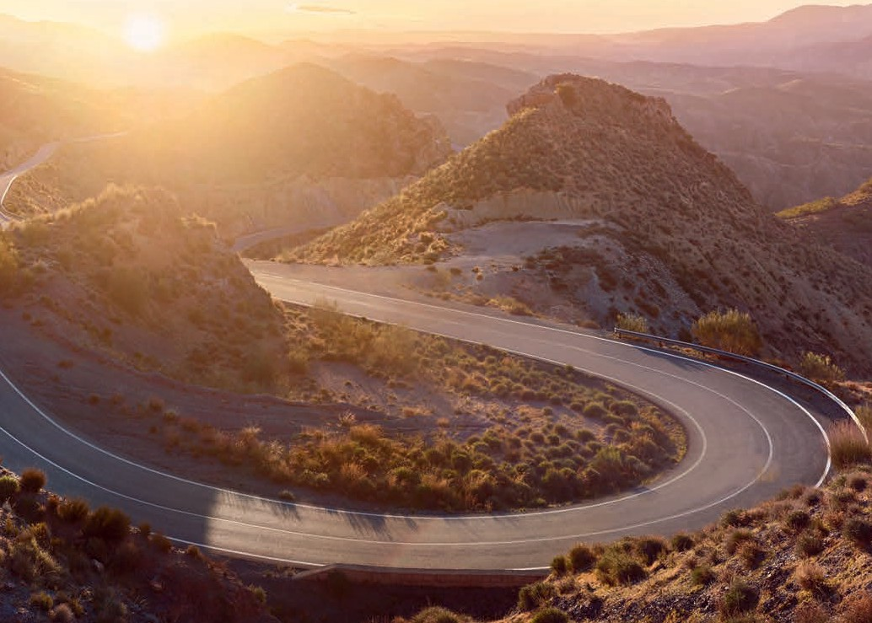

5 good reasons to choose Renault Trucks

Renault Trucks is the ideal partner for completing your mission successfully. We are relentless in seeking out new solutions to provide you with the best support and to meet your requirements.
Our network of experts, our reliable, robust and comfortable vehicles, combined with adapted and connected services are so many good reasons to choose Renault Trucks!

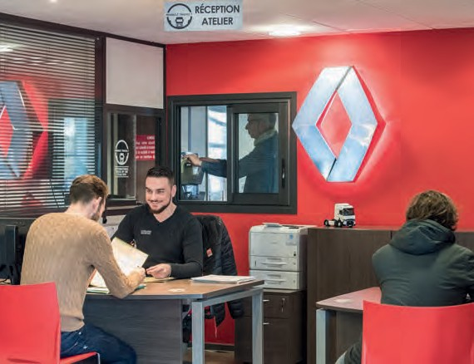
A NETWORK OF PROFESSIONALS
1
at your side and at your service

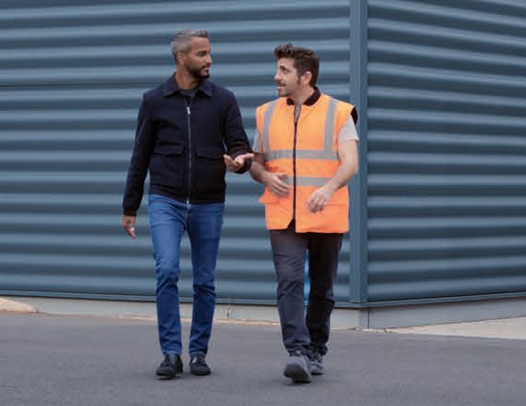
SERVICE OFFERS
2
at your side for your entire journey

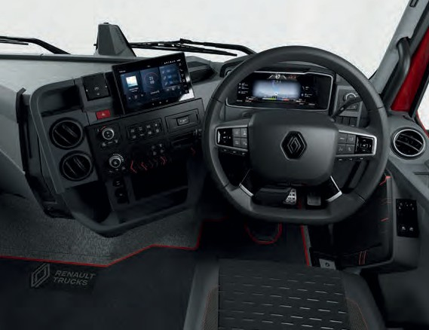
NEW DRIVER INTERFACE
3
with equipment that has been redesigned with your comfort in mind

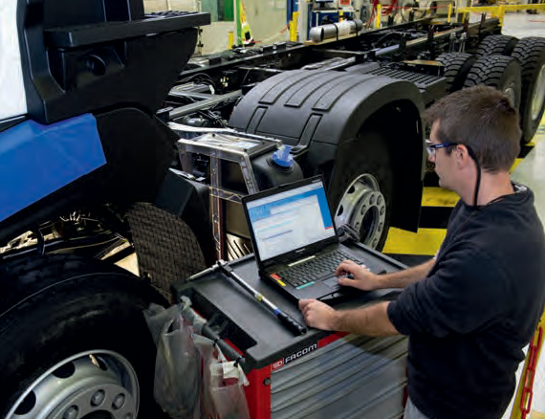
TECHNOLOGY AND ENGINES
4
that are increasingly efficient to save fuel

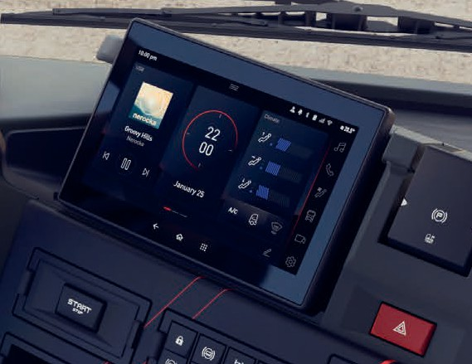
NEW SAFETY EQUIPMENT
5
to reassure you in your daily activities

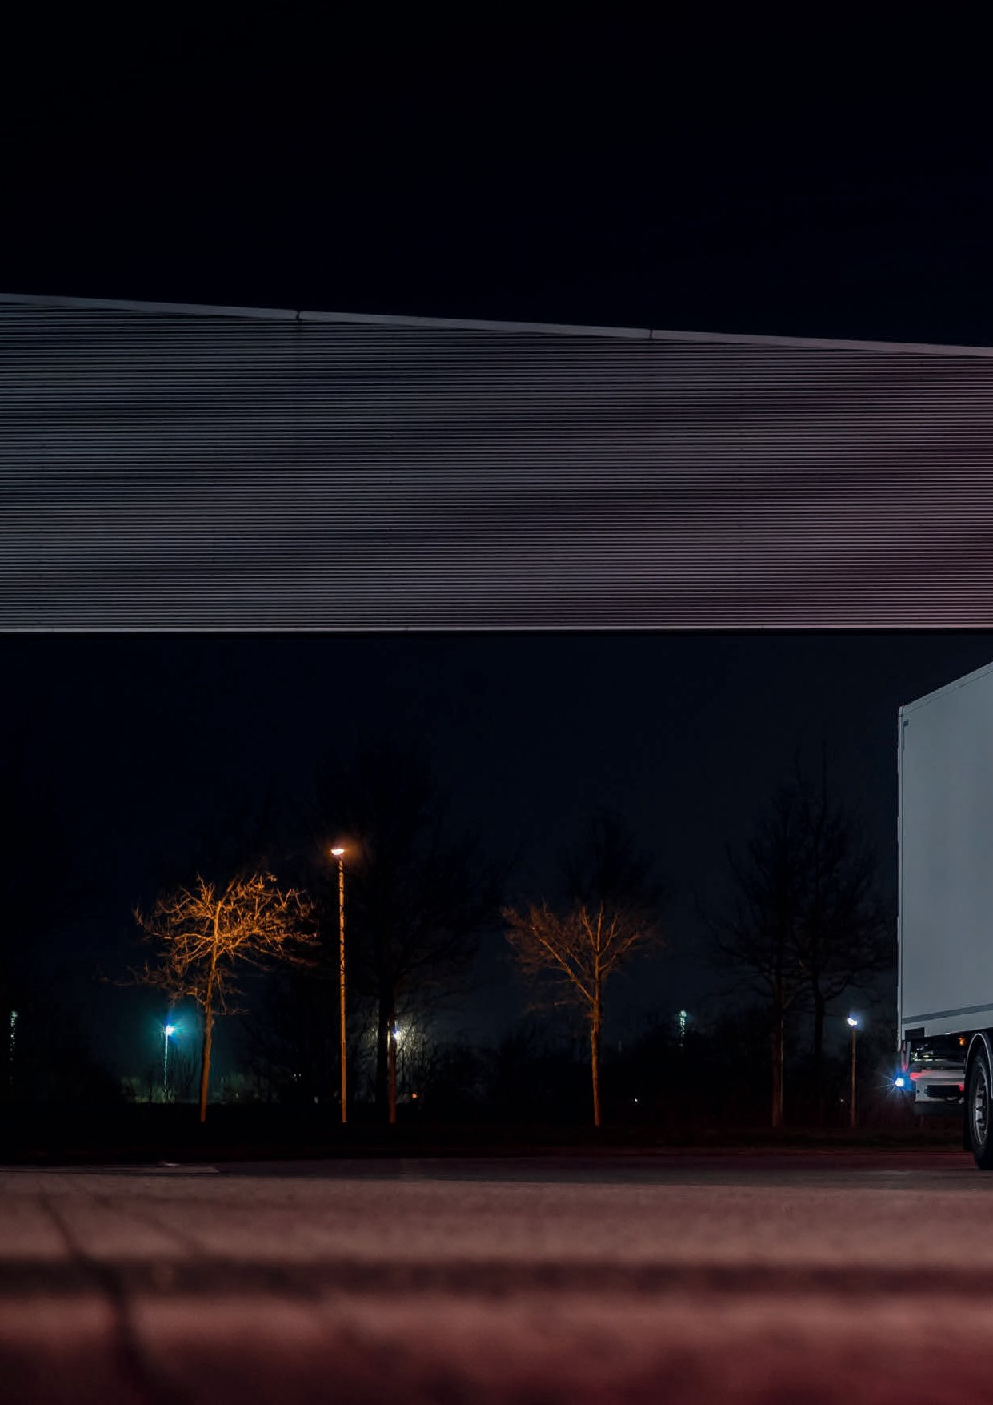
Renault Trucks T / T HIGH 06

An extensive service helping you to optimise
your productivity
Renault Trucks vehicles are connected, allowing you to benefit from service offers to ensure maximum uptime of your truck. This makes Renault Trucks the best partner to optimise your vehicle’s operating time, optimise its full potential and plan for the unpredictable. Enabling you to manage your activity with total peace of mind.

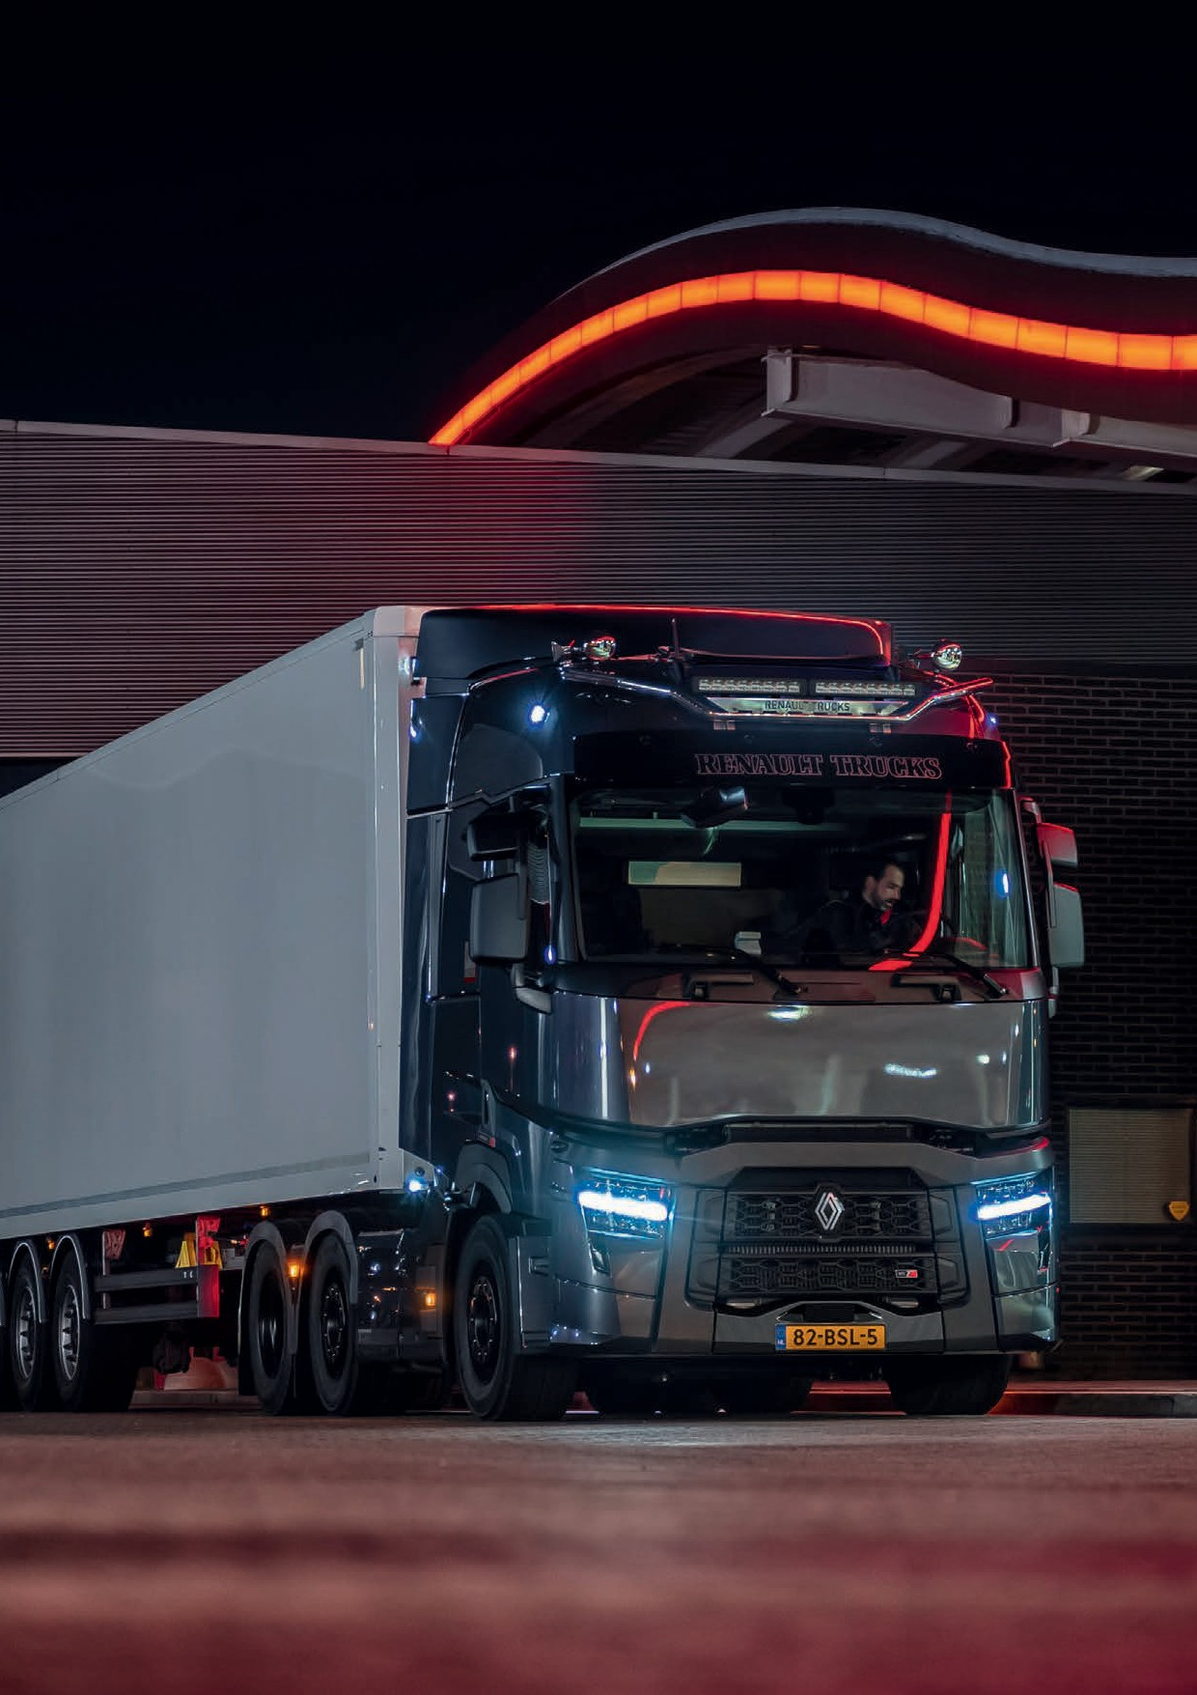
Renault Trucks T / T HIGH 07

« Renault Trucks is the best partner for completing my mission successfully ».

Experts at your side, at your service
Experts, trained technicians
Extended opening hours, including Saturday mornings* Fast appointments for repairs and maintenance
*Depending on Renault Trucks authorised dealers.



Rely on our qualitative parts and assistance


2-Year warranty on our parts and labour
A 2-year warranty on parts breakdown and recovery warranty for all operations carried out by an approved Renault Trucks dealer.

Our Genuine parts Our Reman offer

Choose quality genuine parts: reliable, robust and approved to maintain vehicle performance.
A range of remanufactured parts that meets the same technical requirements as new parts to guarantee perfect compatibility with your vehicle.






Diagnosis and repair 24/7
With a network of experts ready to answer you in 16 languages, you are backed by
a coordinator who will remain your sole contact throughout the entire operation. Breakdown repairs are carried out by technicians trained in roadside operations using specially equipped vehicles and dedicated diagnostic tools.

Drive with complete peace of mind
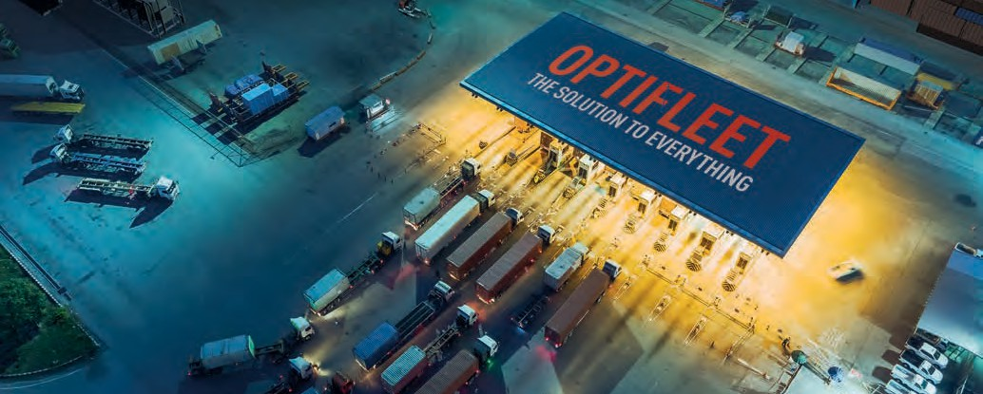

Make the most of your fleet with our Optifleet solution


REDUCE YOUR ENERGY CONSUMPTION

Optifleet Check
Monitor your vehicle's performance (fuel consumption, topography, speed)
Improve your driver's driving style thanks to the Ecoscore personalised report


DRIVE WITH COMPLETE PEACE OF MIND

Optifleet Map
Allows you to plan your routes


SAVE TIME

Optifleet Drive
Allows you to download tachograph data remotely, so there is no need
for vehicle downtime

VIEW THE STATE OF

HEALTH OF YOUR VEHICLES

Optifleet Health
Monitor your vehicle instrument panel warnings in real time
Avoid time off the road due to breakdowns


REDUCE ACCIDENTS AND WEAR OF YOUR VEHICLES

Optifleet Safety
Monitor events linked to vehicle safety
Improve the safety of your drivers and road users
Identify risky behaviour

Maximise availability and control your maintenance costs with Start & Drive Predict

MAINTENANCE AND REPAIR COSTS COVERED
Avoid unforeseen costs: a Start & Drive Predict contract controls your costs.

CONNECTED AND CUSTOMISED MAINTENANCE PLAN
We consider uptime as crucial. Our maintenance planning and grouping maintenance operations together are designed to minimise downtime to suit the actual use of your vehicle. Your vehicle’s original performance levels are maintained by following Renault Trucks, recommendations.

PREDICTIVE MAINTENANCE
With Start & Drive Predict, benefit from data monitoring in real time in order to:
Optimise maintenance Anticipate breakdowns

REMOTE SERVICES
You can connect to your vehicles even if they are not moving, and update software without needing to stop the vehicle.

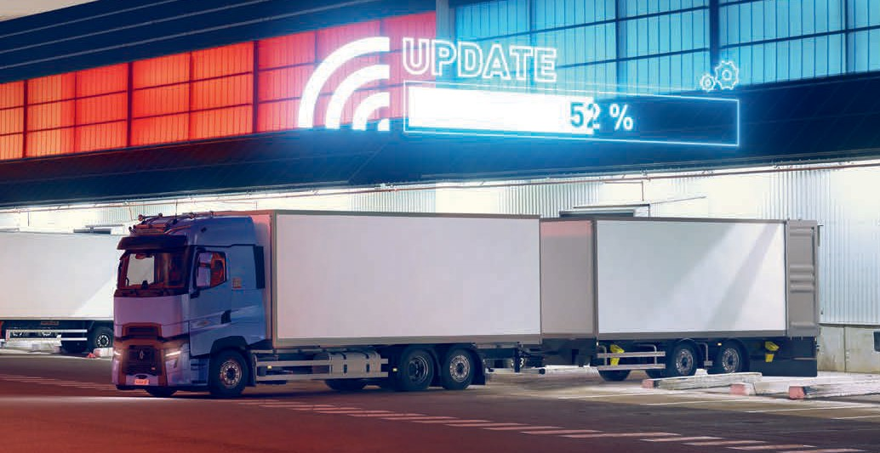

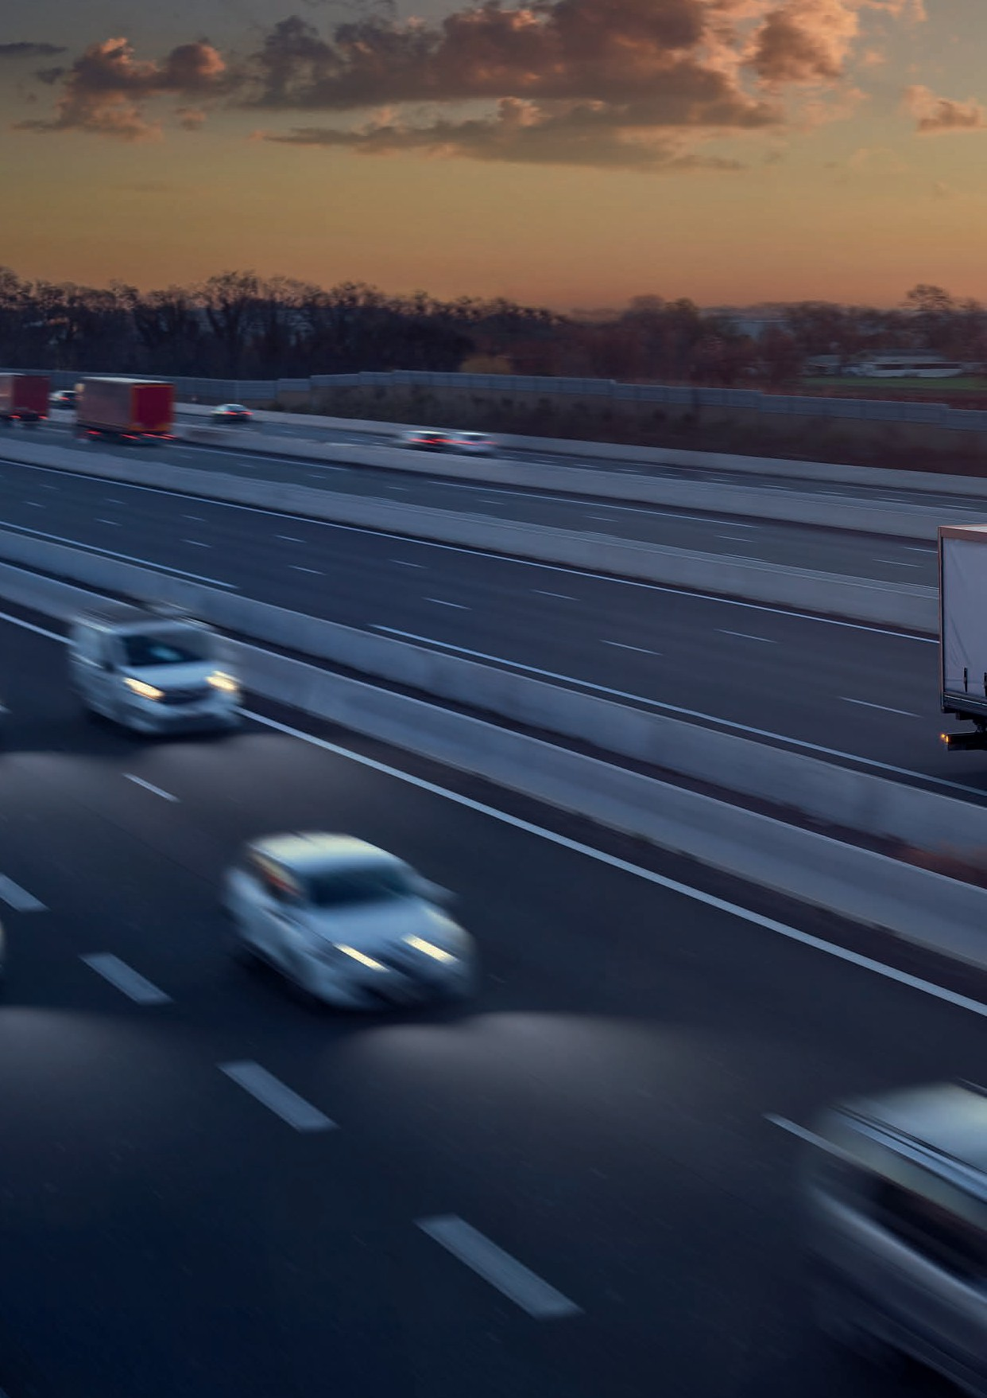
Renault Trucks T / T HIGH 12

Simple and efficient vehicles help control your costs
Building on their many years of haulage experience, designed with proven technologies and the results of quality surveys, the Renault Trucks T and T High are acknowledged to be extremely dependable vehicles. They are quite simply perfect for making every trip profitable - and with their outstanding fuel efficiency, they are a real asset for your business.

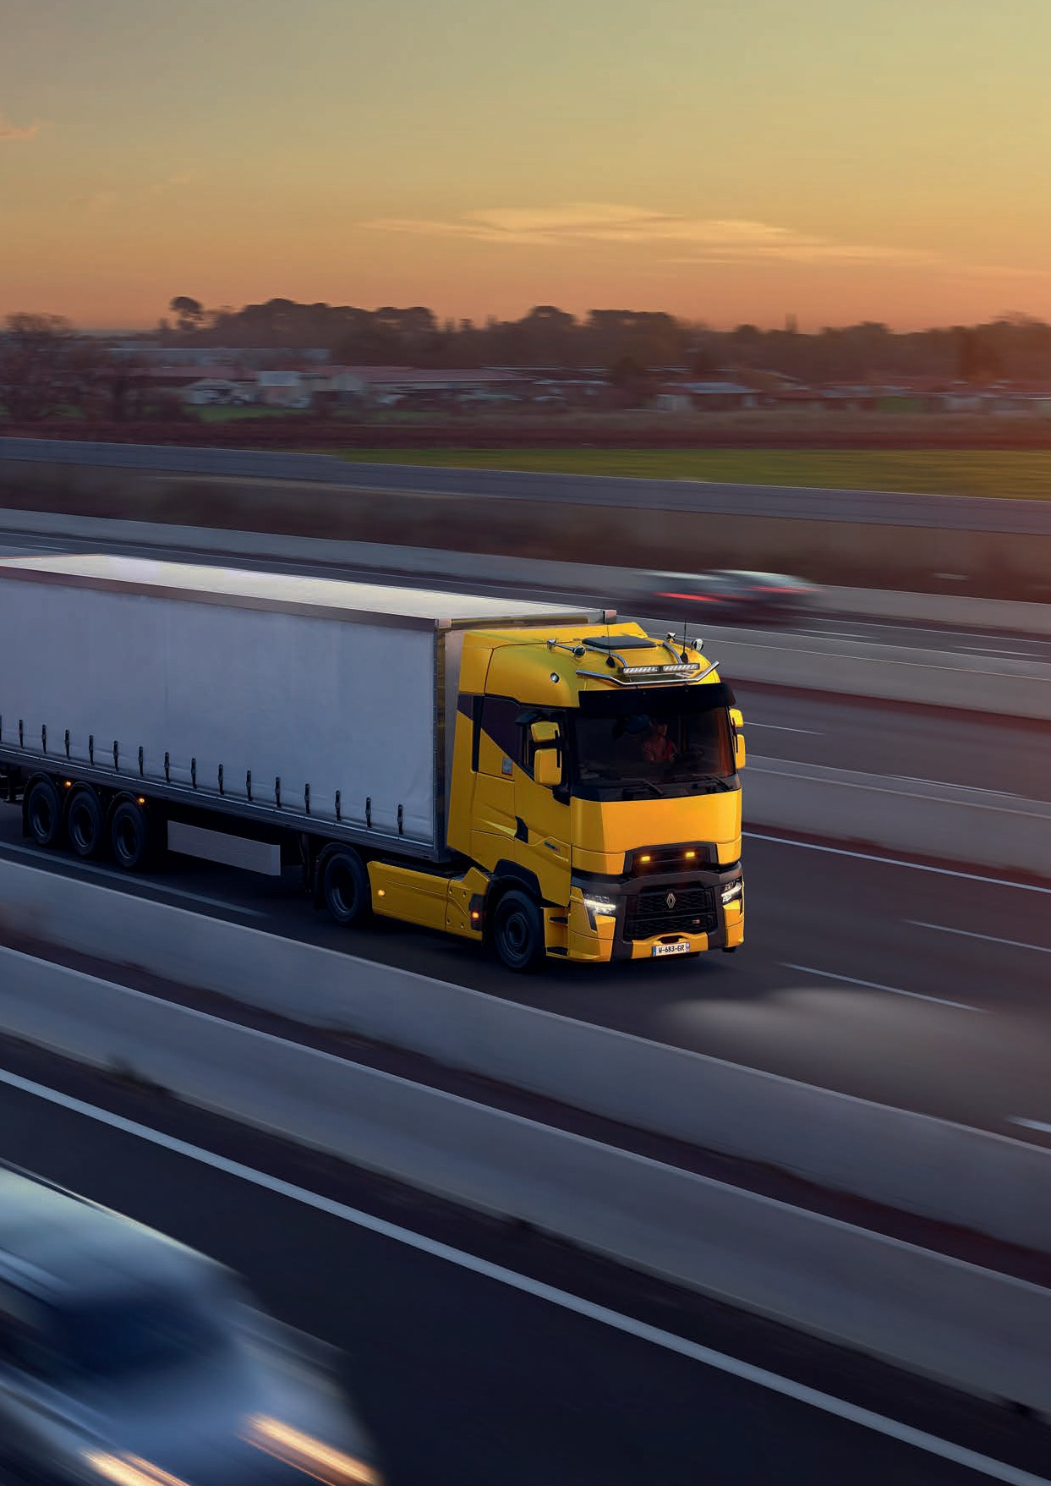
Renault Trucks T / T HIGH 13

« With the Turbo Compound, we have lowered fuel consumption by 3L/100 km compared to our previous trucks ».

A driveline designed for fuel economy

We are relentless in our quest for efficiency and we will provide you with the optimum fuel efficiency for your vehicle use.
Thanks to the Turbo Compound, you can achieve up to a 10% reduction in CO₂ emissions and fuel consumption

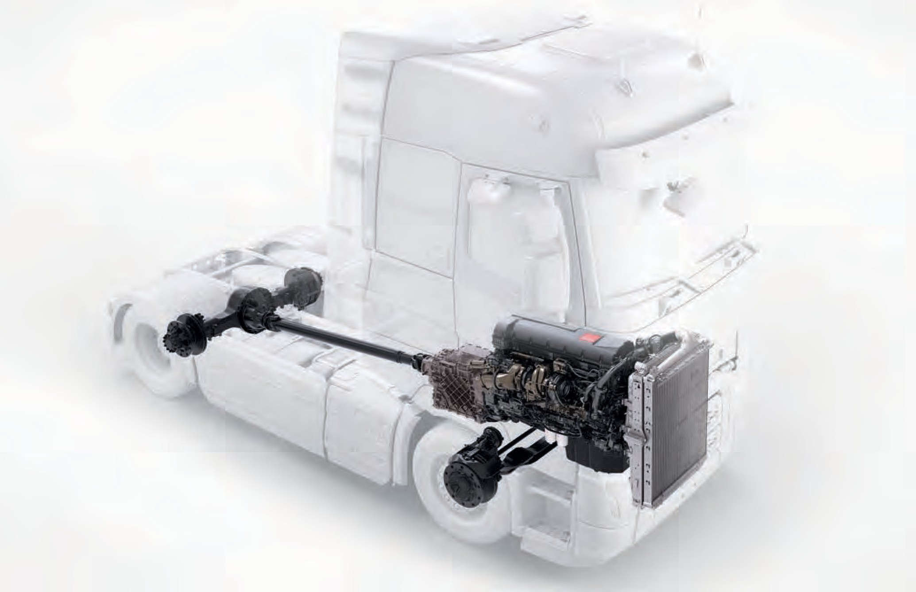
3
1
2

Greater reliability and fuel savings :


DE11, DE13 and DE13 Turbo Compound engines and adapted oil change intervals
1


Category A tyres as standard Optimised axle ratios
2
3

Our engines benefit from:

TURBO COMPOUND TECHNOLOGY
ENGINE COMBUSTION IMPROVED THANKS TO :
- Wave pistons
- New injectors
- Latest-generation filters

REDUCTION OF PARASITIC LOSSES
- Engine friction improvement
- Ball bearing Turbo compressor
- Electrical controlled variable steering pump
- New further efficient brake air compressor
- Even more efficient lubricants

The latest update of
the Optidriver gearbox :
Which allows for 30% quicker and smoother gear shifts
Dedicated Optivision software
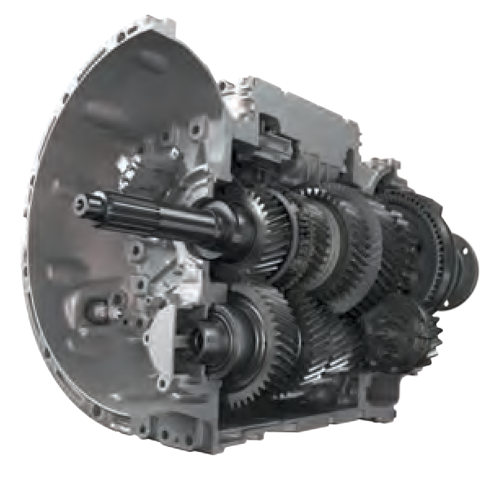

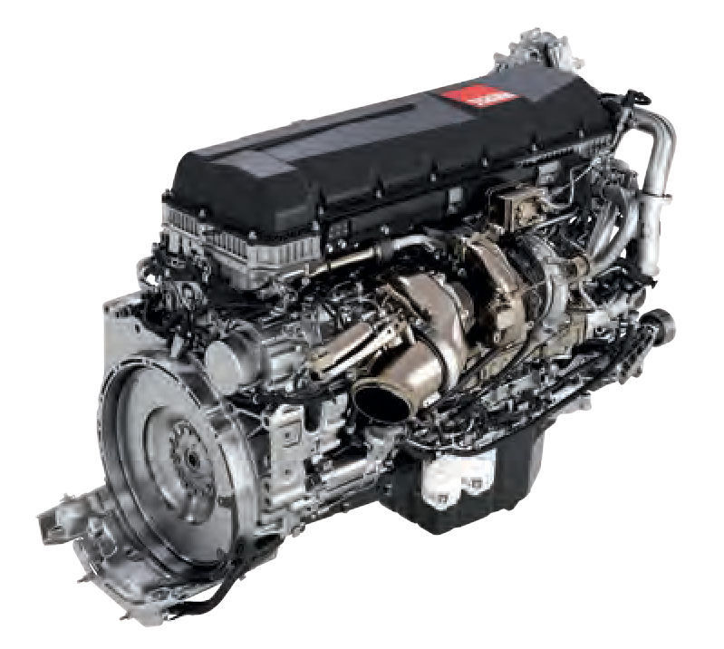
Our engines, combined with the new technology and services, are part of an effort to decarbonise diesel vehicles through the reduction of CO₂ emissions

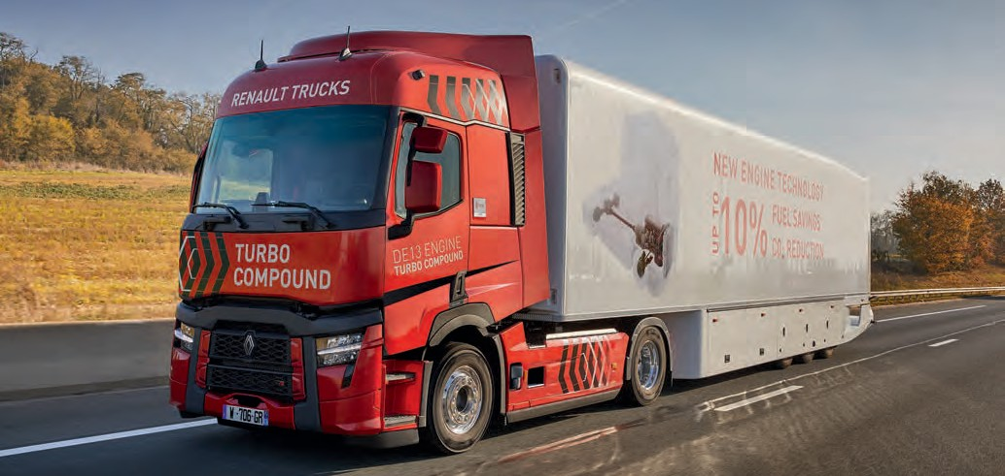

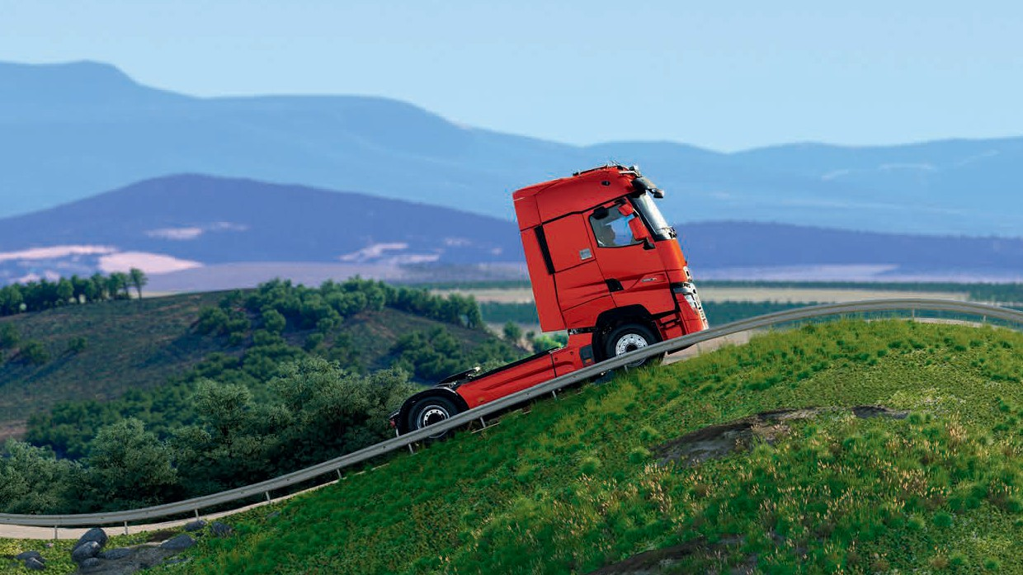
Technology for controlling your costs
2
During the climb: no change of speed
3
1
Before the climb: acceleration
Before descending: switch to
free-wheeling

The Renault Trucks T and T High are equipped with technologies making it significantly easier to drive more economically.

OPTIVISION MAP BASED
This option uses topographical data. Data transmission to the on-board computer is automatic and continuous throughout the journey, before starting each new incline ➊, ➋, ➌ and for driving downhill ➍, ➎.
The gear shift, acceleration and speed strategies are optimised, which further reduces fuel consumption.




Go further in controlling your costs with Optifleet
(see page 10)

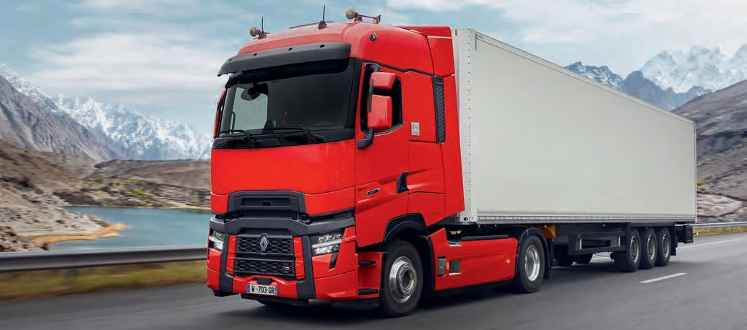

ECO CRUISE CONTROL
This option includes two driving modes, which can be selected manually by the driver:

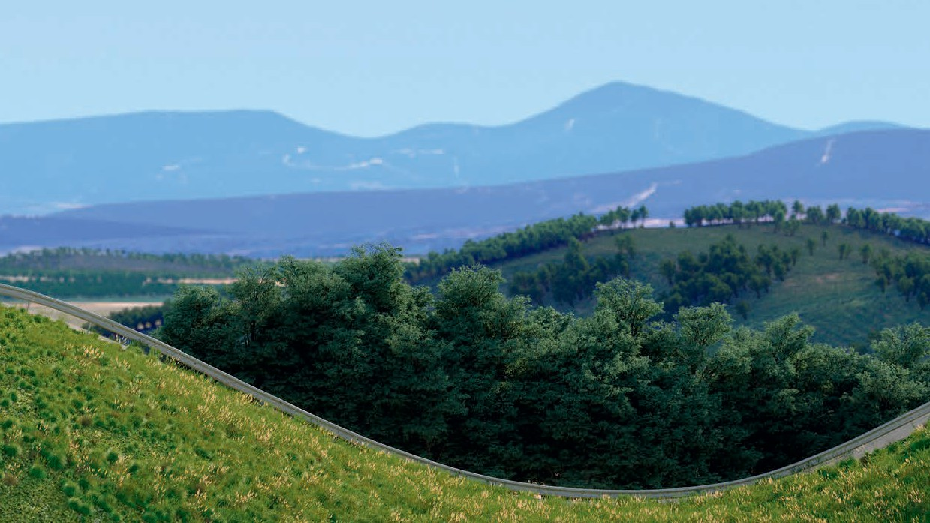
Fuel Eco On (default mode)
4
During descents: braking always under control
5
In the hollows: extra momentum
It optimises fuel consumption by intervening with certain driving actions such as acceleration, gear shifting, cruise control or even deceleration.

Fuel Eco Off
It can change the way the vehicle is being driven. An indicator
provides real-time information about the driving style being adopted.

Aerodynamic design

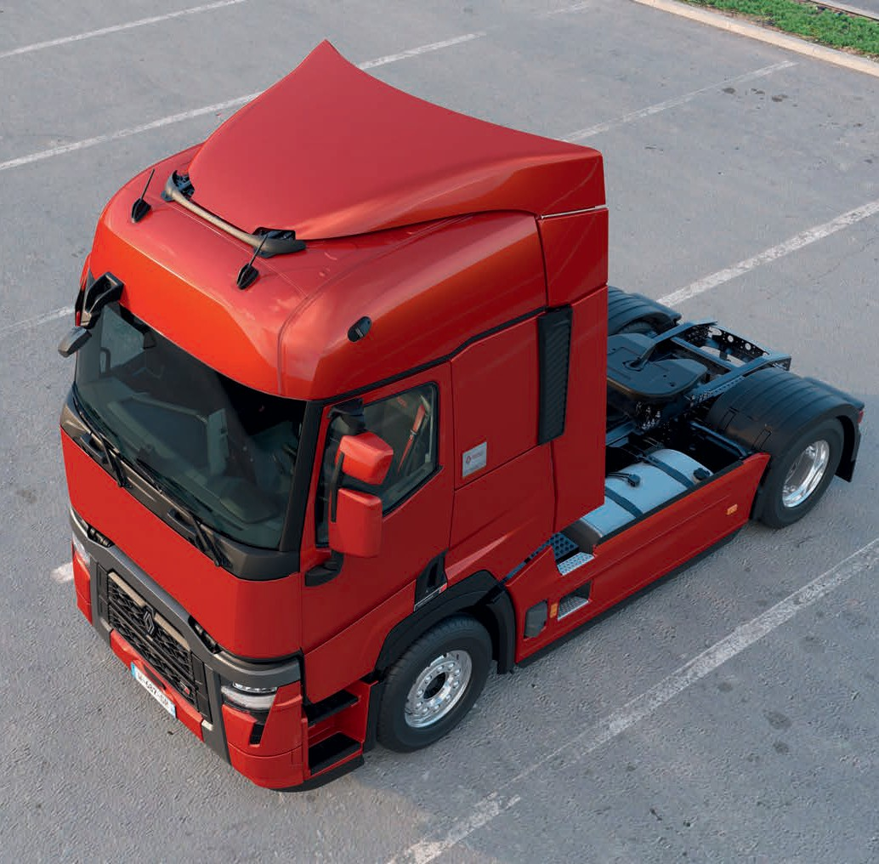




1
2
4
5
7
3
6


Different types of roof deflectors Fixed (88 mm), electrically or manually adjustable (from 285 to 496 mm) - folding lateral deflectors.
1


12° Windshield inclination Bumper with integrated spoiler Trapezoid cab
2
3
4
2.3m at the front and 2.5m at the rear.

Fairing extentions

On door and Wing extensions, on 4x2 chassis fairings.
5


Deflector incorporated into the optical block
6
Wheel arches
7
Improve air flow and reduce water splashes.

All-in-one financing

Your financial partner, fluent in Trucks.

At Renault Trucks Financial Services, we speak your language and offer many financial solutions (Hire purchase, Financial & Operating leases, Contract Hire), adapted to your needs. Our complete solutions allows you to fully control your total cost of ownership.



100% PEACE OF MIND

Renault Trucks

*All contracts pages 40-41
Service contracts*
(Reference, Performance & Excellence)
Financing

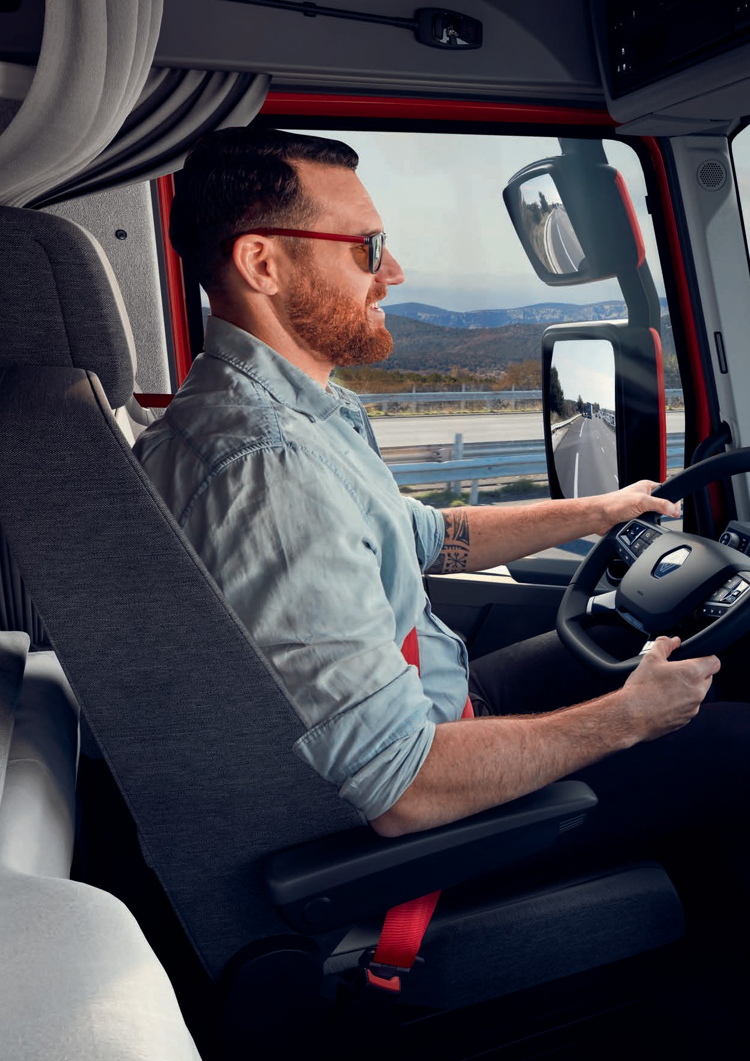
Renault Trucks T / T HIGH 20

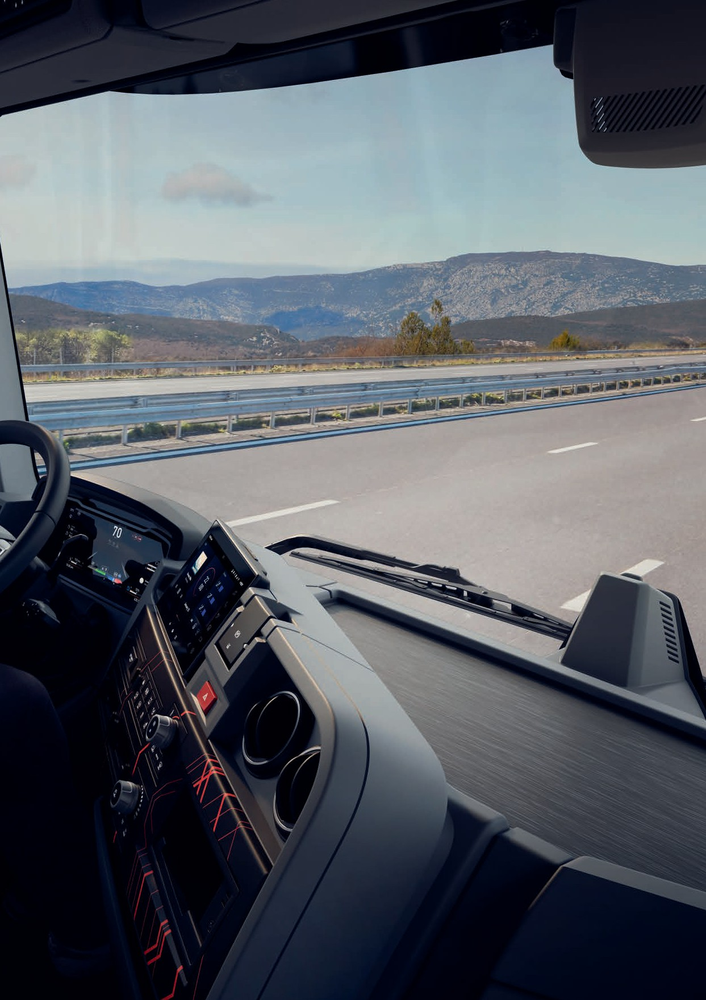
Renault Trucks T / T HIGH 21

A new, optimised interior promoting driver well being
On board a Renault Trucks vehicle, the smallest details have been studied to combine convenience and ergonomics.
Everything needed to create a genuinely homely atmosphere, at the wheel and during stopovers.

« The steering column allows a great deal more comfort, the driving position is much better ».
LHD Panoramic Dash Shown. (Compact Dash with RHD)

Outstanding driving comfort
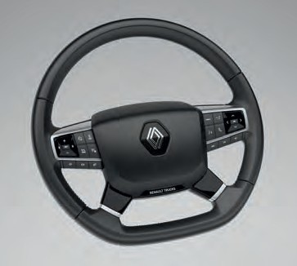

Steering wheel NEW
1
1
Functionality at your fingertips
Keyless vehicle starting using the start button
2
Smooth gear shifts thanks to the Optidriver gearbox
3
Smart direction indicator management NEW
4
Induction charger* NEW
5

2 USB-C plugs
6
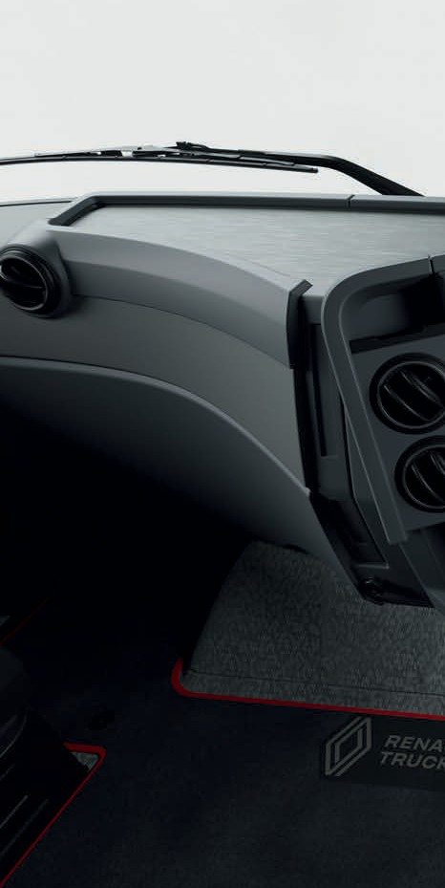
*optional
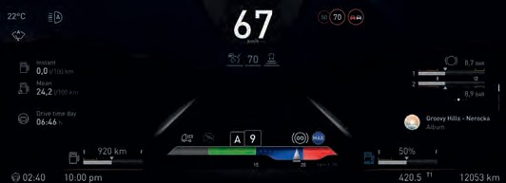
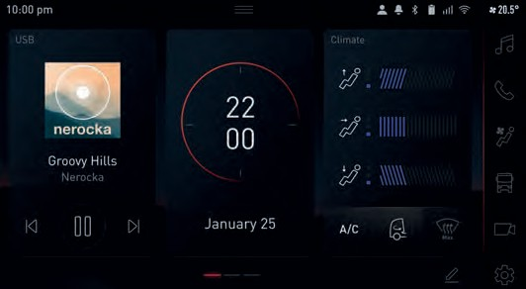
7 A modernised dashboard NEW
New dynamic, digital information display
8 A multifunction screen NEW
9-inch HD touch screen
Driver aids (cameras, navigation)
Multiple applications for configuring the vehicle screen
- Call management
- Music control

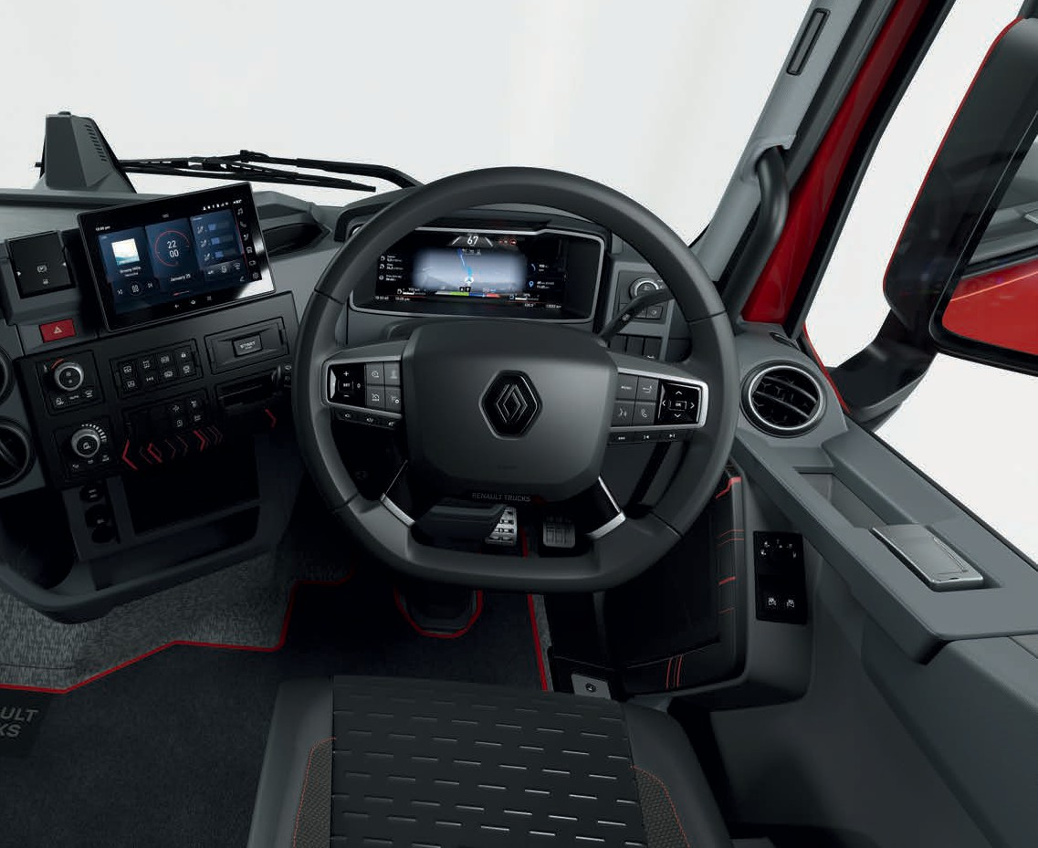


1
8
7
2
3
4
6
5
9

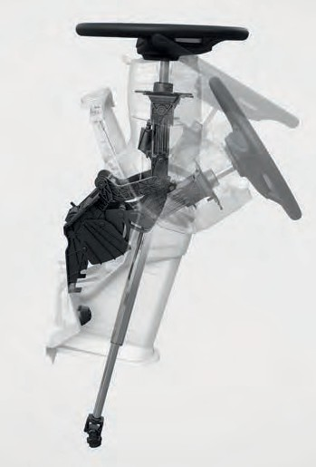
One of the best steering column on the market
9 Multidirectional column
3 adjustable points so you can adapt the driving position to suit your needs
Intuitive foot control on the steering column to determine your ideal driving position
Easy access to the cab when the steering wheel is in the raised position
More knee room
Engine vibrations absorbed for more comfort

A living area just like home

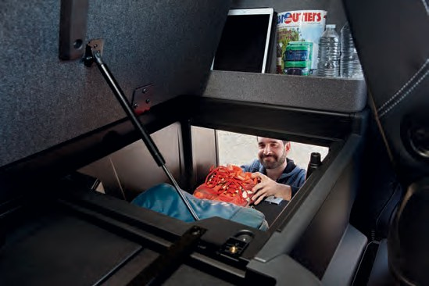
Interior / exterior storage
1
1
Makes loading heavy luggage easier (holding a pack of 6 1.5L water bottles)
Integral storage pocket to keep belongings in place and near the bunk

Front storage compartments
2
Within easy reach above the dashboard

Cup holder*
3
within easy reach

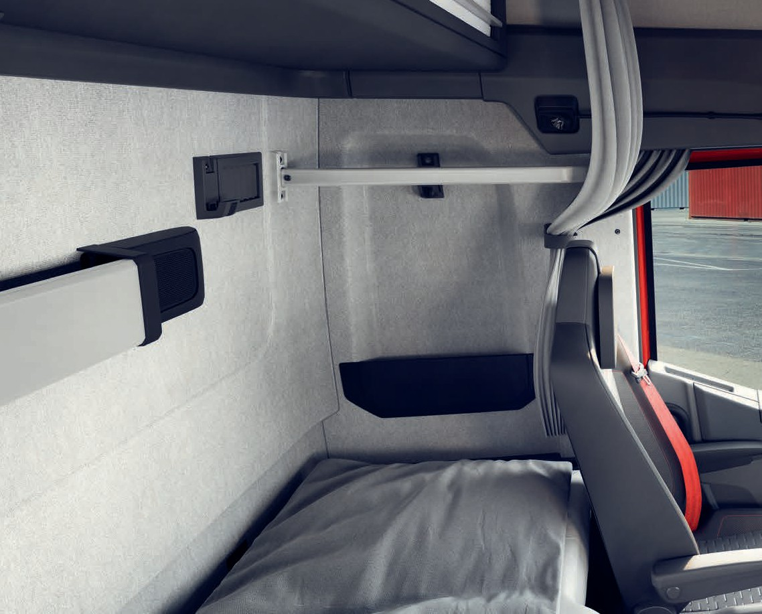

*optional
1
1

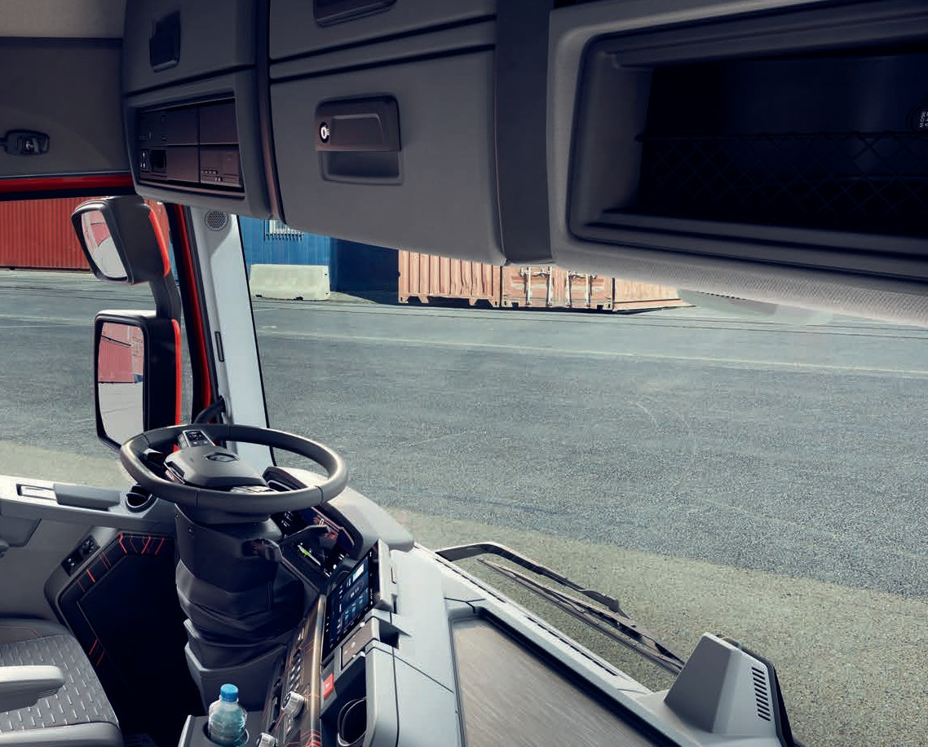
Silent electric refridgerator*
4
2
3
LHD Panoramic Dash Shown. (Compact Dash with RHD)
40 litre capacity or 26 litre on a T
*only on T High

Two USB-C outlets
in the bunk
5

Ultra-comfortable Sérénité lower bed*
Length 2018 mm
6
Width 671 mm behind the seats, 791 mm in the centre
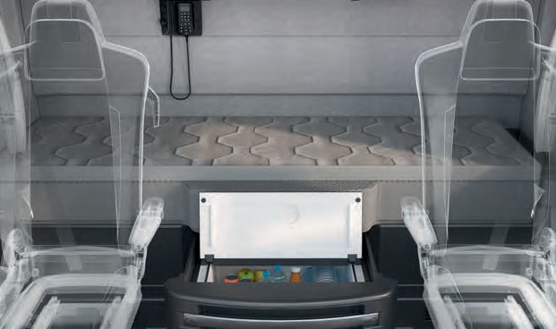
Twice the springs and a thicker mattress capable of adapting to all body types
5
6
4
Mattress can be separated from its base to add a fitted sheet
New, easily cleaned textured fabric Memory foam mattress*
(2000 mm x 700 mm x 30 mm), filling 300 g / m3, fabric to match the bunk upholstery
*optional

Personalise your truck

Dashboards

COMPACT
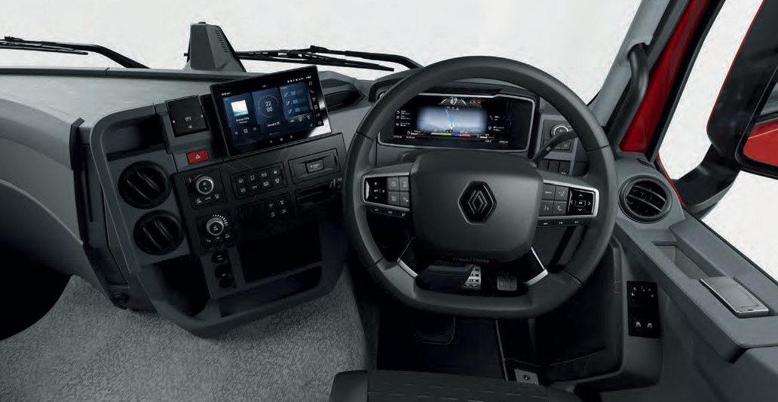

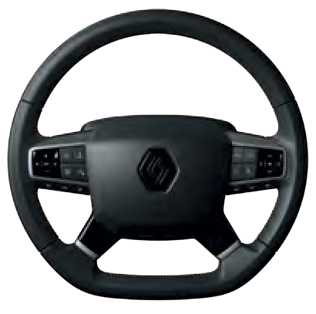

Leather (available with red stitching and foam)

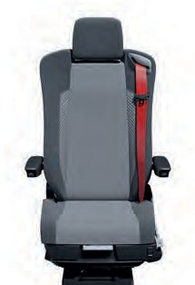
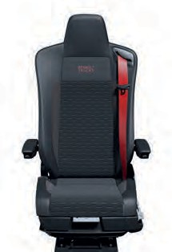
Textile Leather and textile

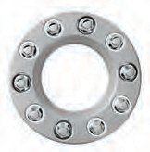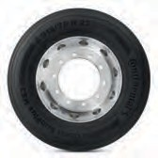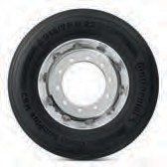

Metal disc + chrome nut covers
Alcoa matt brushed aluminium rims
Alcoa Dura-Bright aluminium rims

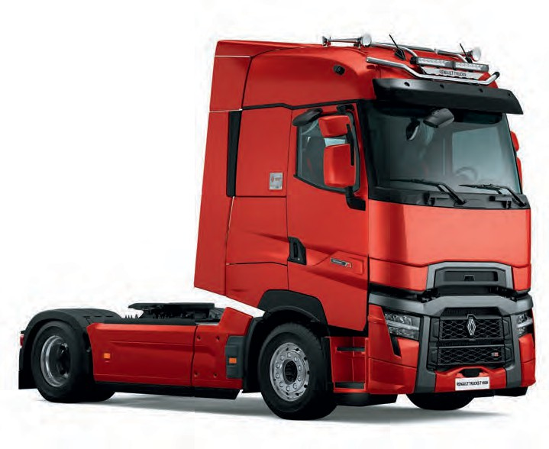

Exterior paintings adaptations
Personalise your vehicle with our extensive range of paintwork options. This work, of a high quality is made by our experts in our plant.
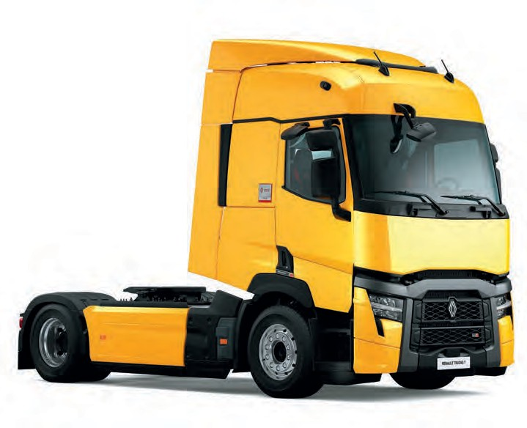
Renault Trucks makes its expertise available to you, to provide you with a completely personalised truck that is quickly available.

NO. | DESCRIPTION
F1 | Mirror bracket
F2 | Mirror liaison bracket
F5 | Pi |  |  |  |  |   F8
F6  F7 F8 | Corner (without grilles and  without attachment pads)  Central bumper Mirror cover | F2  F10  F1 |  |  |  | F11
F10 | Mirror covers
F11 | Handles |  |  |  |  |  |  |   F5
F13 | Towing yoke trim pieces |  |  |  |  | F13
F14 | Front grilles |  |  |  |  | F27 | F14
F27 | Headlight trims for plastic bumper |  |  |  |  |  | F7 |  |   F6
NO. | DESCRIPTION
F3 | Upper Pi internal grille
F4 | Upper Pi interior
F9 | Sunvisor |  |  | F15 F17 |  | F9
F12 | Upper Pi
F15 | Moulding strip trim |  |  | F16
F16 | Air Intake trim
F17  F18 F19 | Mirror cover  Wheel rim  (steel version only)  Door lock |  |  |   F19  F20 |  | F12  F4 |  | F3
F20 F21  F26 | Upper and rear fenders Exhaust cover plate Steps (right-hand and  left-hand) | F18 | F21 | F20  F18 | F26

Accessories for even more comfort
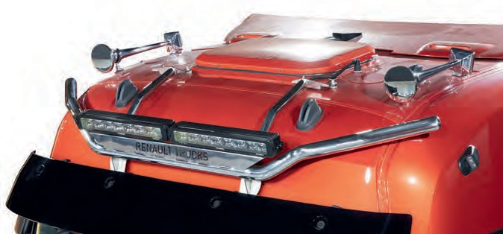
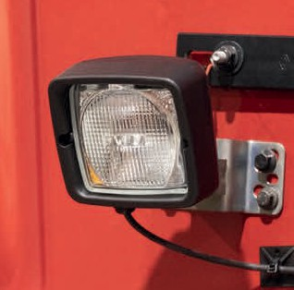
Bi-leds roof bar White working light

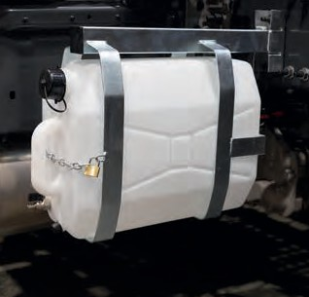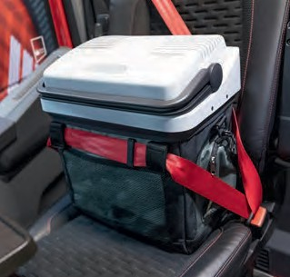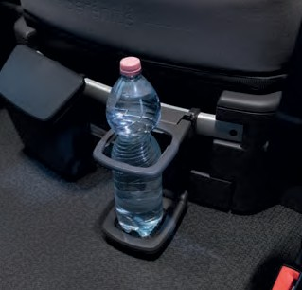

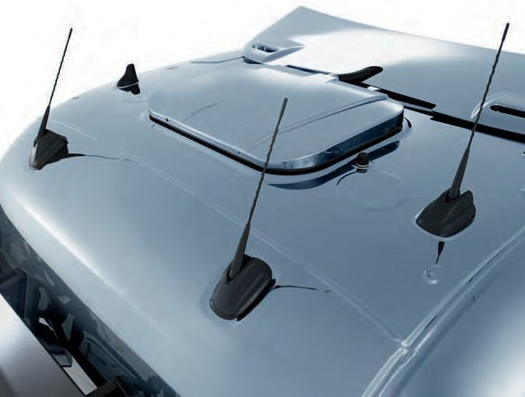
Water fountain

Independent air conditioner
Cooler Bottle holder*
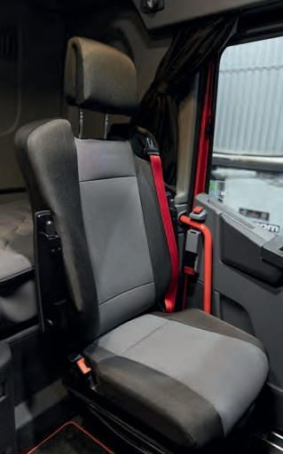
New Force seat covers

*standard on vehicle with a bunk

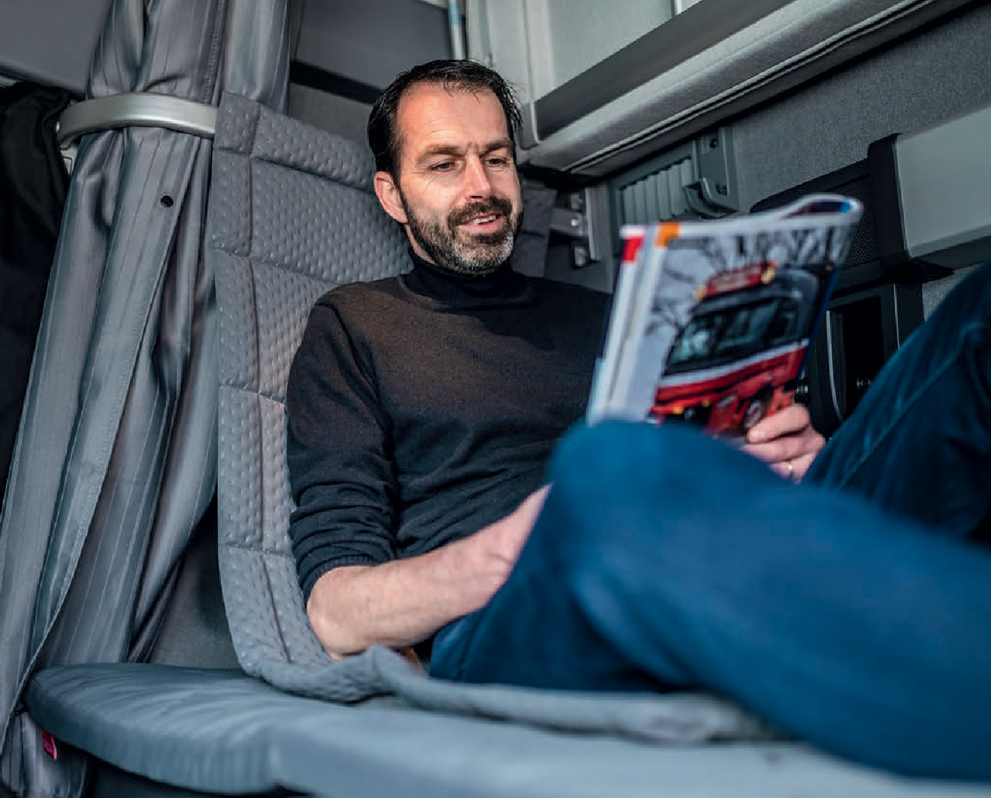
Backrest cushion and mattress topper
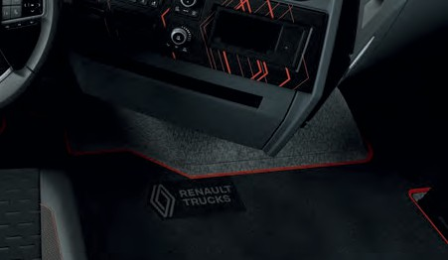

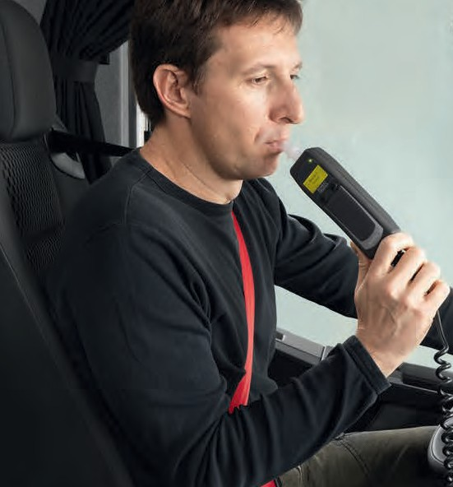
Alcohol ignition interlock device
Floor mats
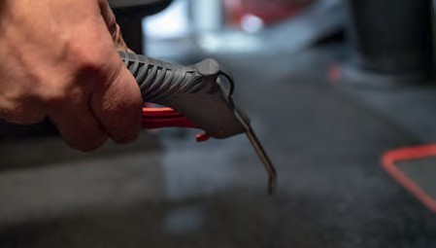
Air blower

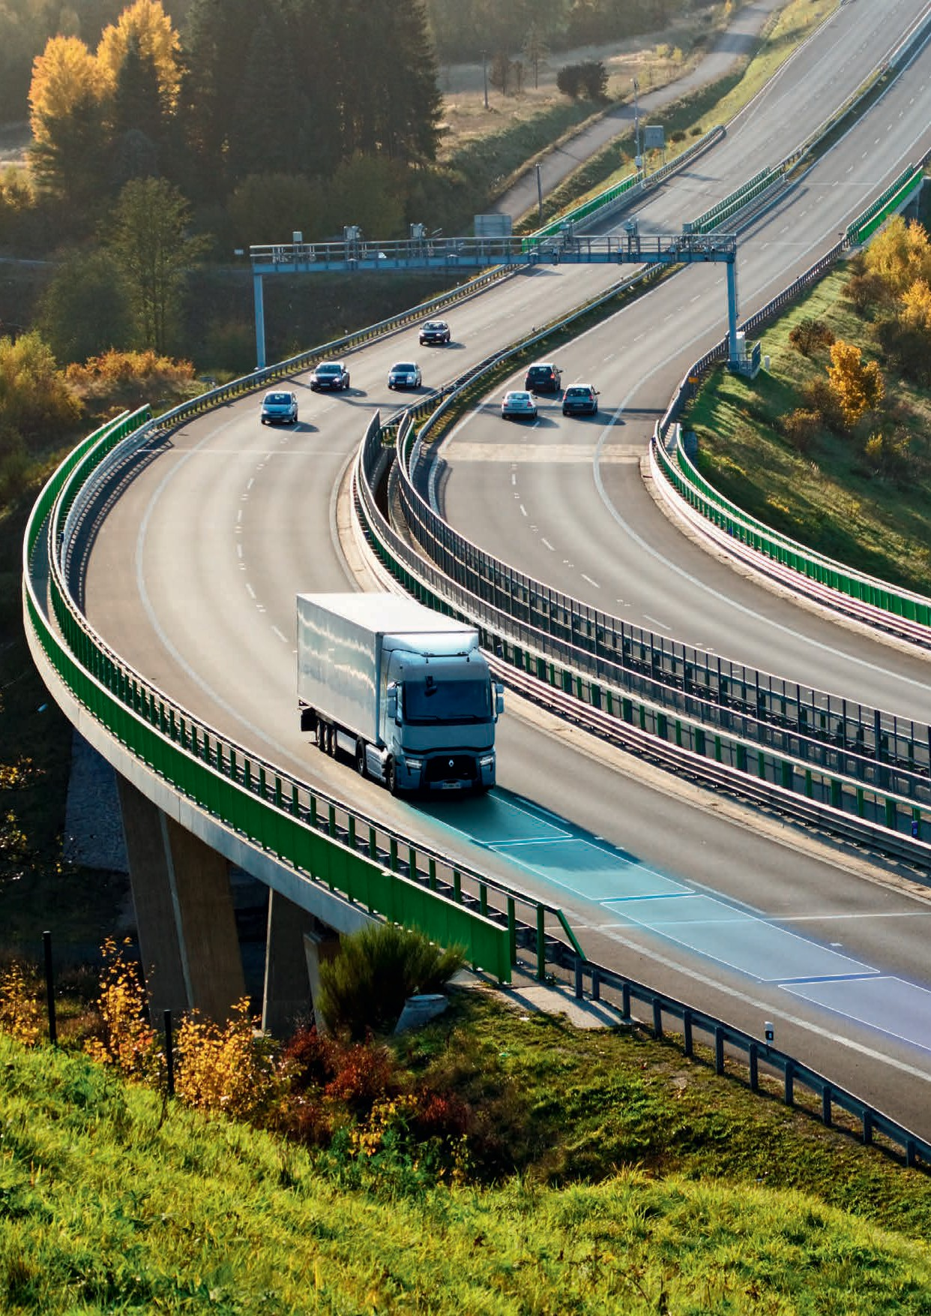
Renault Trucks T / T HIGH 30

« All of the controls and instrumentation lights are within reach and sight! ».

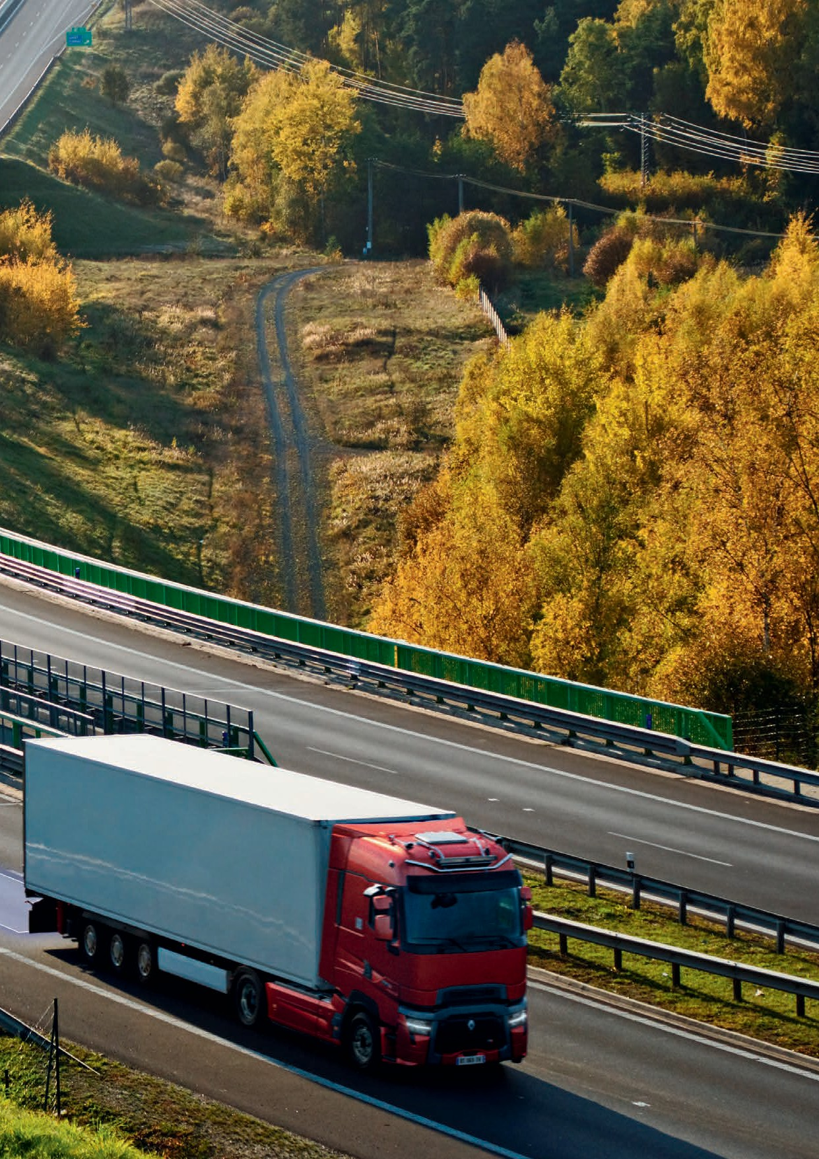
Renault Trucks T / T HIGH 31

Technology serving security
The Renault Trucks T and T High feature the latest driver assistance technologies and the most efficient braking systems. This guarantees driver safety, as well as that of pedestrians, cyclists and other road users.

Safety equipment to support you
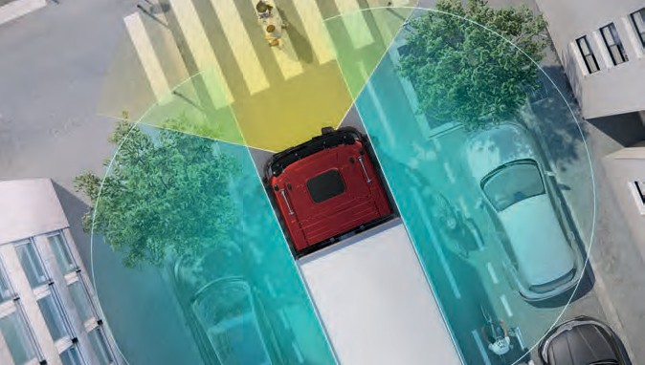
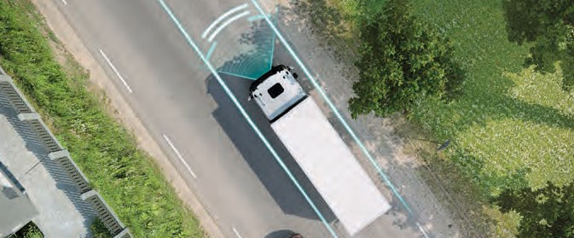
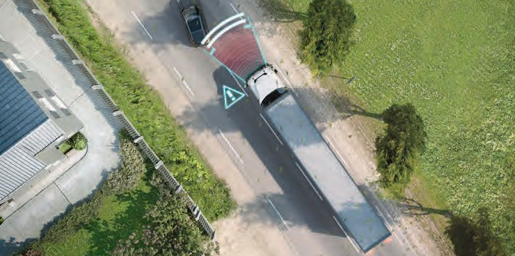

Radars and cameras located all around your truck NEW
They warn you and alert you to ease your manoeuvres. You prevent any risks of accident.
Possibility to add 5 digital cameras to monitor the load or the fifth wheel for docking*
Possibility to provide an analog camera for the trailer to monitor maneuvers*.
*On request for adaptation

Driver fatigue detection and lane departure warning system (LDWS/DDAW*)
Audible and visual warning if a lane departure is detected or if the vehicle is following an unexpected trajectory.
*Lane Departure Warning System / Driver Drowsiness & Alertness Warning

Automatic Emergency Braking System (AEBS) Warns of a possible collision, then brakes and stops the vehicle if no action from the driver.
The hazard warning lights are activated automatically.

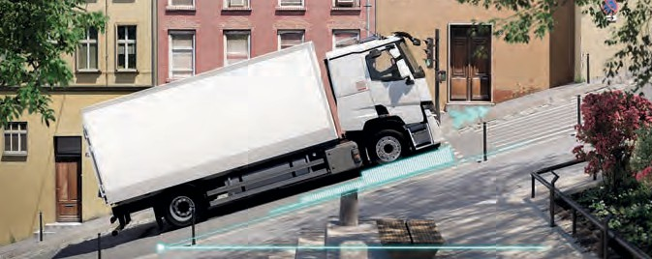
Autohold
Automatically manages braking when starting to climb, making it easier to set the vehicle in motion and prevent it from rolling back.

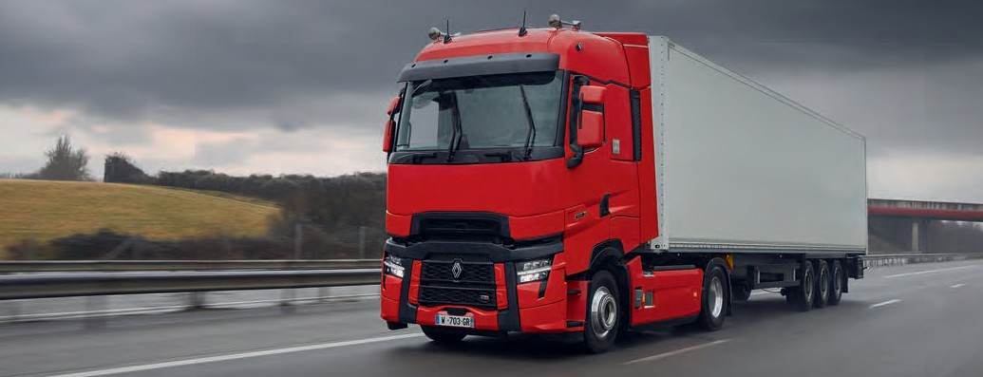
1

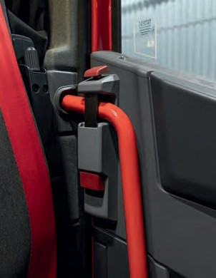
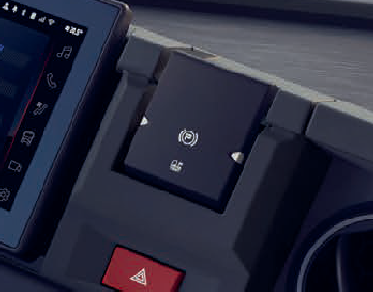
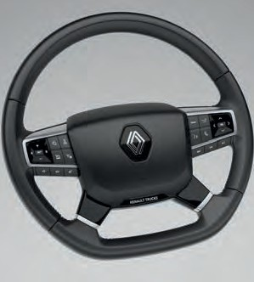
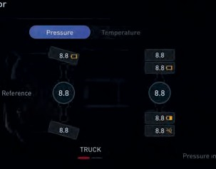
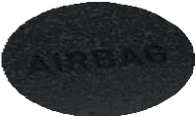

Automatic activation of headlights and windscreen wipers
2
6
3
7
4
5
1
Improves visibility and allows the driver to concentrate on the road

Tire Pressure Monitoring System (TPMS) NEW
2
Located on the rims of the truck and of its body, the sensors warn you and alert you on any problems about tire pressure or temperature, which provides you peace of mind
AIRBAG

Antirunaway mode(1)
3
Emergency parking brake application(1)
Stopping the vehicle in case of driver’s mishandling(1)

Mechanical anti-intrusion locking(1)
4
For greater safety in the cab when the vehicle is parked (1)

Speed Assistance* (ISA**)
5
NEW
The camera recognises the prescribed speed limit and warns the driver if this is exceeded,
to avoid any accidents or penalties
*available depending on geographical location
**Intelligence Speed Assistant
Driver Airbag(1) NEW
6
The airbag is deployed in the event of a serious frontal collision

Yellow painted cab access steps / handles(1)
7
Improves safety when getting into and leaving the vehicle

(1) Optional

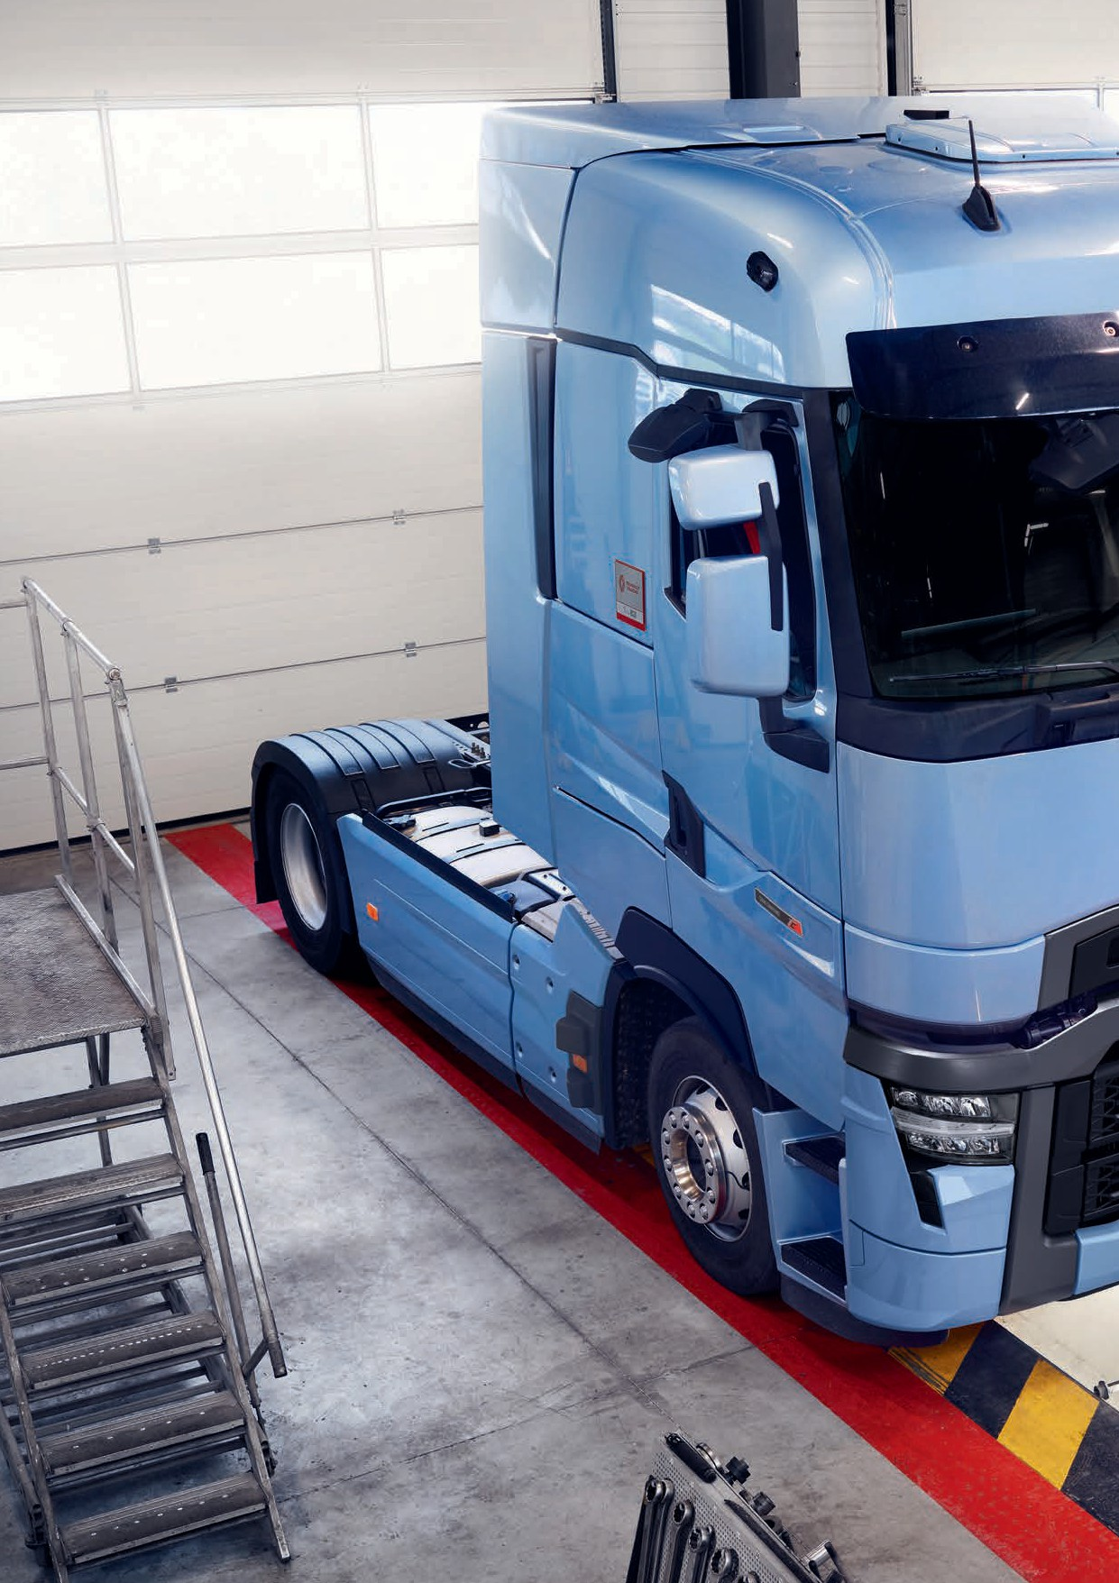
Renault Trucks T / T HIGH 34

To find out more...

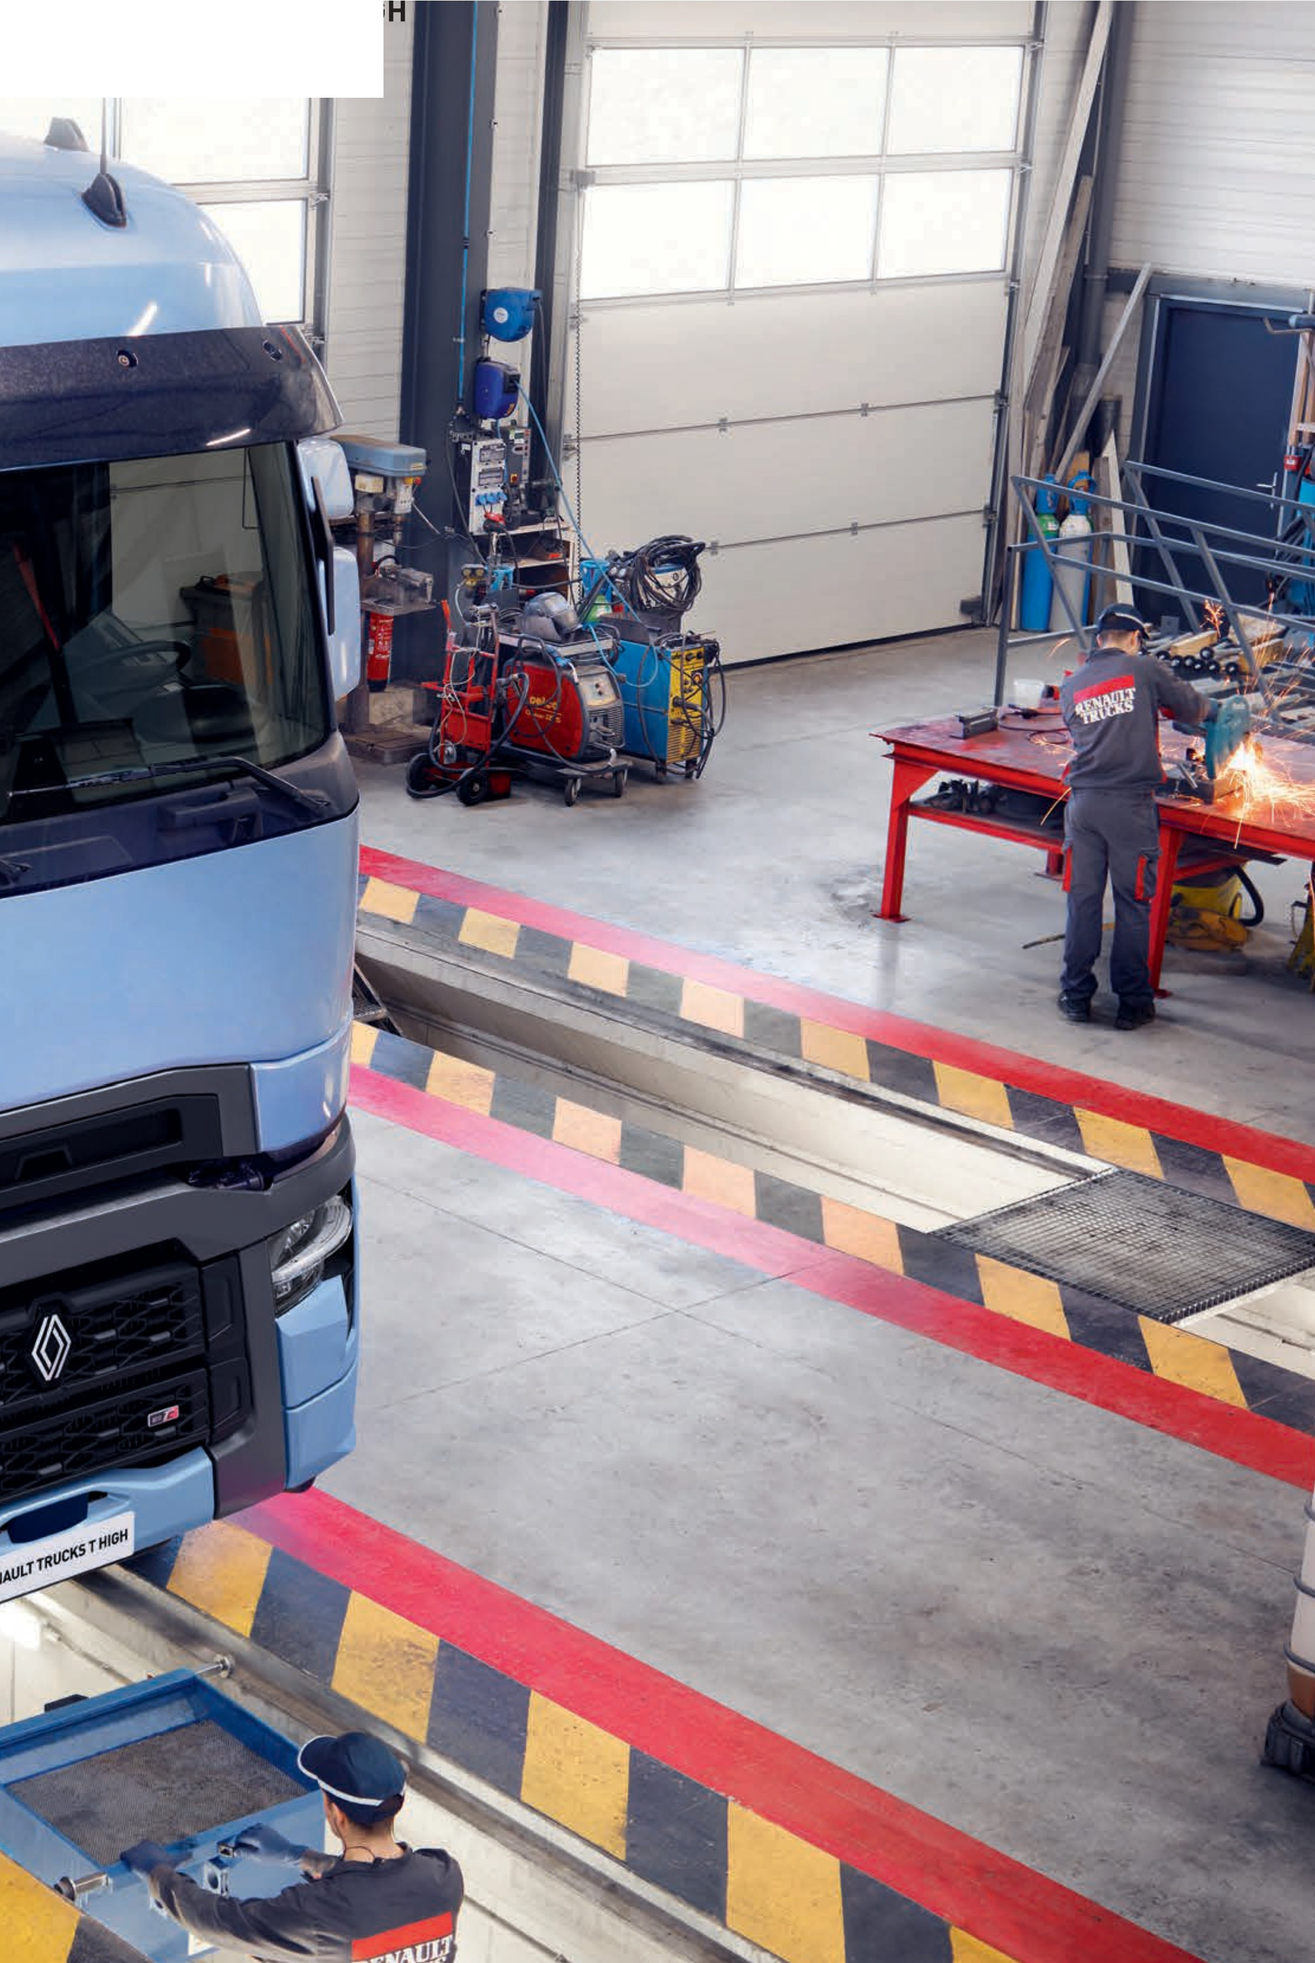
35
Renault Trucks T /

Range poster

Cab

Day cab ** Night & Day cab
Sleeper cab

Silhouette
Type
Tractor
Rigid
Tractor
Rigid

4x2 6x2 pusher
axle/ 6x2 trailing
axle 4x2 6x2
4x2

6x2 pusher

Chassis height
GVW
19 t
26 t
19 t
26 t
19 t
26 t
19 t
26 t

X-LOW LOW MEDIUM

LOW MEDIUM

X-LOW LOW MEDIUM

Engine
GCW
40 t
44 t
60 t
40 t
44 t
60 t

DE11

DE13 DE13 TC*

Gearbox

Robotic gearbox Optidriver (12)

Robotic

High
axle/
DE13
*
gearbox

Sleeper cab
6x2 trailing axle

4x2 6x2
LOW MEDIUM
DE13 TC
Optidriver
(12)

* DE13 TC (Turbo Compound) available as an option on 480 hp. ** DE13 TC not available on Day cab.
Power
380 hp
430 hp
460 hp
480 hp
520 hp
480 hp
520 hp

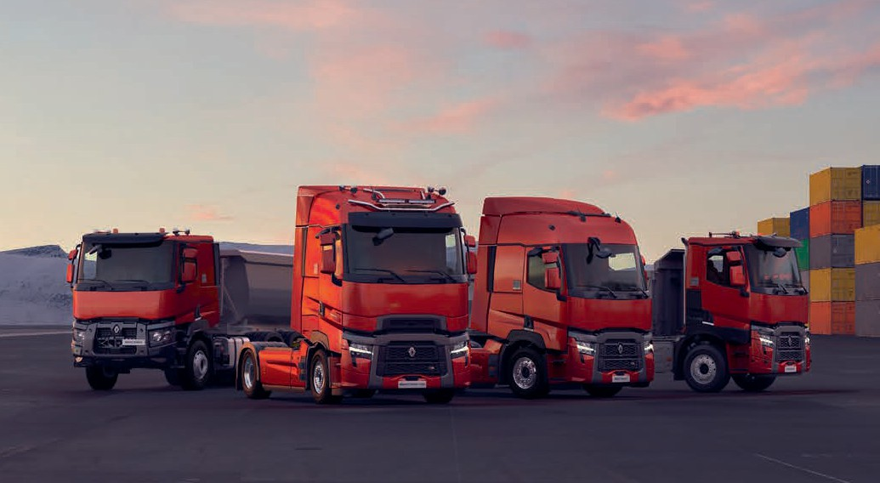

Driveline

DE11 EURO VI ENGINE
285 kW (380 hp) – 1800 Nm
323 kW (430 hp) – 2050 Nm
344 kW (460 hp) – 2200 Nm

DE11 - 380 hp

DE11 - 430 hp

DE11 - 460 hp

Displacement
10,8 l
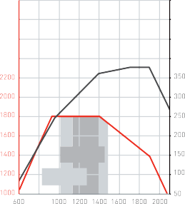
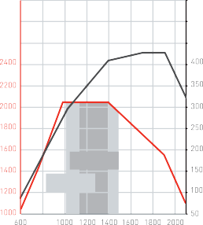
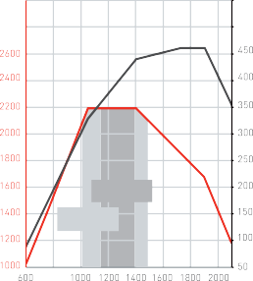
Cylinders 6 in line
Distribution
Rear
380 hp (285 kW)
1700-1900rpm
1800 Nm
938-1400rpm
Fuel Eco+ 1150-1380rpm
Fuel Eco 1000-1500rpm
430 hp (323 kW)
1700-1900rpm
2050Nm
1008-1400rpm
Fuel Eco+ 1150-1380rpm
Fuel Eco 1000-1500rpm
460 hp (344 kW)
1700-1900rpm
2200 Nm
1050-1400rpm
Fuel Eco+ 1150-1380rpm
Fuel Eco 1000-1500rpm
Bore 123 mm
Stroke
152 mm

Compression ratio 18:1
965 kg
Weight (including oil)
Nm
Engine Speed (rpm)
hp Nm
Engine Speed (rpm)
hp Nm
Engine Speed (rpm) hp

DE13 EURO VI ENGINE
330 kW (440 hp) – 2200 Nm
360 kW (480 hp) – 2400 Nm
390 kW (520 hp) – 2550 Nm

DE13 - 440 hp

DE13 - 480 hp

DE13 - 520 hp

Displacement
12,8 l
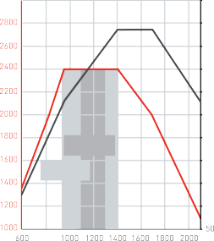
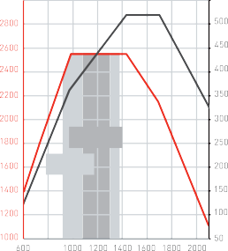
Cylinders 6 in line
Distribution
Rear
440 hp (330 kW)
1404-1700rpm
Fuel Eco+ 1100-1300rpm
Fuel Eco
0-1400rpm

90
Nm 0rpm
2200
925-140
480 hp (360 kW)
1404-1700rpm

2400 Nm
960-1400rpm
Fuel Eco+ 1100-1300rpm
Fuel Eco 900-1400rpm
520 hp (390 kW) / 1431-1700rpm
2550 Nm
990-1400rpm
Fuel Eco+ 1100-1300rpm
Fuel Eco 900-1400rpm
Bore 131 mm
Stroke
158 mm

Compression ratio 18:1
1 067 kg
Weight (including oil)
Nm
Engine Speed (rpm)
hp Nm
Engine Speed (rpm)
hp Nm
Engine Speed (rpm) hp

DE13 TC EURO VI ENGINE
360 kW (480 hp) – 2700 Nm
DE13 TC - 480 hp

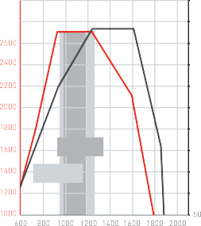
Cylinders 6 in line
900-1250rpm 1250-1600rpm
2700 Nm
480 hp (360 kW)
Fuel Eco+ 950-1200rpm
Fuel Eco 900-1300rpm
12,8 l
Displacement
Bore 131 mm
Rear
Distribution
Compression ratio 18:1
1 196 kg
Weight (including oil)
158 mm
Stroke
Nm Engine Speed (rpm) hp

Cabs
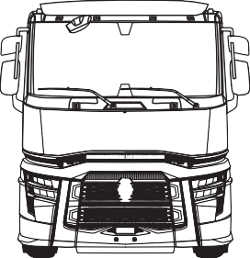
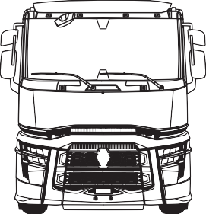
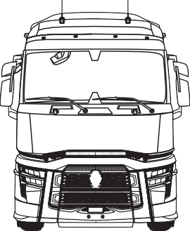
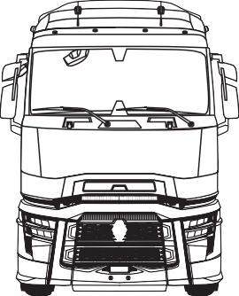

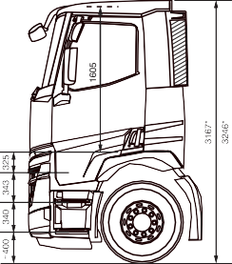
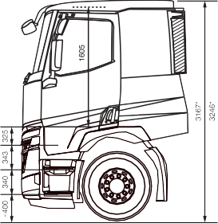
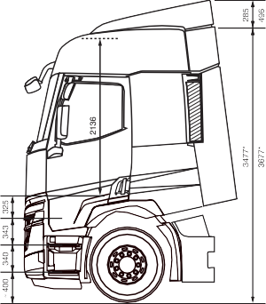
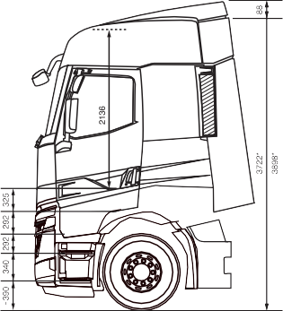

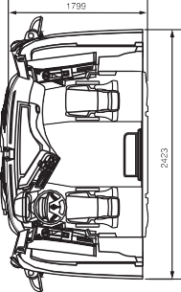
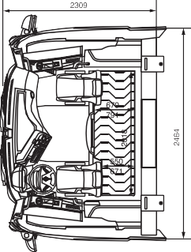
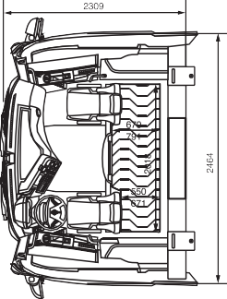
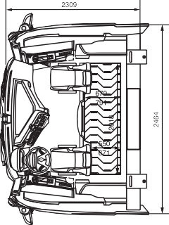

Short cab Standard roof
Type

Deep cab Standard roof

Deep cab High cab roof
Deep cab High cab roof Flat floor

Engine tunnel height

1405 mm 1405 mm 1936 mm 2136 mm

Steps 3 3 4
Flat floor
200 mm engine tunnel
200 mm engine tunnel
Floor
2136 mm
2136 mm
1605 mm
1605 mm
Interior height
HIGH SLEEPER CAB
SLEEPER CAB
NIGHT & DAY CAB
DAY CAB
* For 4x2 tractors.

Chassis

PROFILES
6x2 Steering pusher axle
6x2 Pusher axle
6x2 Trailing axle
6x2 Steering axle

4x2



Tractor


Straight truck

WHEELBASE |  |  | 3200 | 3400 | 3500 | 3700 | 3800 | 3900 | 4000 | 4100 | 4300 | 4600 | 4800 | 4900 | 5200 | 5600 | 6000 | 6400 | 6500 | 6700
Straight truck |  | 4x2 |  |  |  | ■ |  |  | ■ |  | ■ | ■ |  | ■ | ■ | ■ | ■ |  | ■ | ■
 |  | 6x2 Trailing axle |  |  | ■ | ■ |  | ■ |  |  | ■ | ■ | ■ | ■ | ■ | ■ | ■
Tractor |  | 4x2 |  |  |  | ■ | ■
 |  | 6x2 Pusher axle |  |  |  |  |  | ■ |  | ■
 |  | 6x2 Trailing axle | ■ | ■ |  | ■

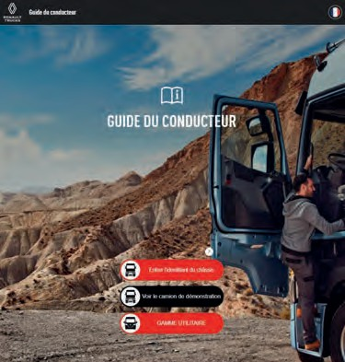
The Renault Trucks driver's handbook


Accessible via this link
It is available for ranges T/C/K produced after July 2021

Contracts for diesel vehicles 0 to 5 years old

- MONITORING OF COMPONENT WEAR
- PREVENTION OF VEHICLE DOWNTIME
- REMOTE SERVICE FOR SOFTWARE UPDATES
- PROACTIVE MANAGEMENT OF MAINTENANCE OPERATIONS
WEAR AND TEAR PARTS*
REPAIRS*
REPAIRS*
PREVENTIVE MAINTENANCE*
PREVENTIVE MAINTENANCE*
PREVENTIVE MAINTENANCE*
CONTRACTS
BREAKDOWN AND TOWING
BREAKDOWN AND TOWING
EXCELLENCE
PERFORMANCE
REFERENCE
*see table for the list of parts and services covered.
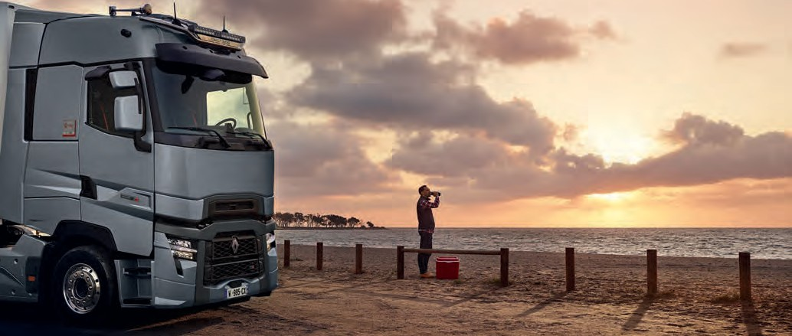

List of parts covered by repair and preventive maintenance

WEAR AND TEAR PARTS
 |  | REFERENCE |  | PERFORMANCE |  | EXCELLENCE
Batteries
Brake discs and drums
Brake linings and pads
Clutch
Engine
Gearbox
Transmission
Final drive axle
Injection system
Air compressor
Emissions control system
Electronics
Suspension
Steering
Chassis cab
Alternator/Starter motor
Engine oil change
Gearbox oil change
Final drive axle oil change
Filter replacement
Drive belts
Particulate filter
Annual checks and services

REPAIR

PREVENTIVE
MAINTENANCE

Notes

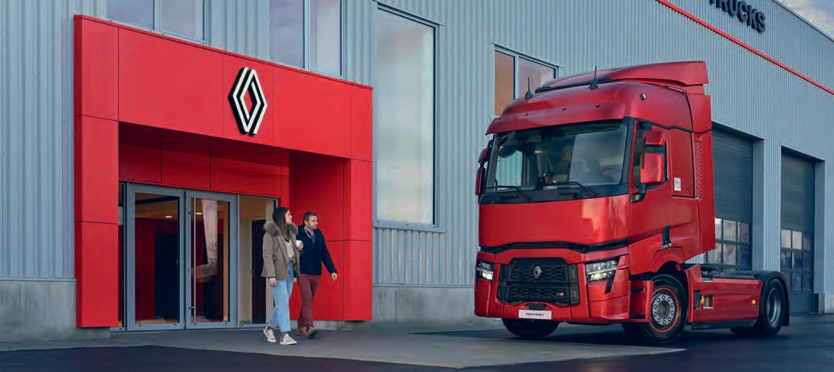

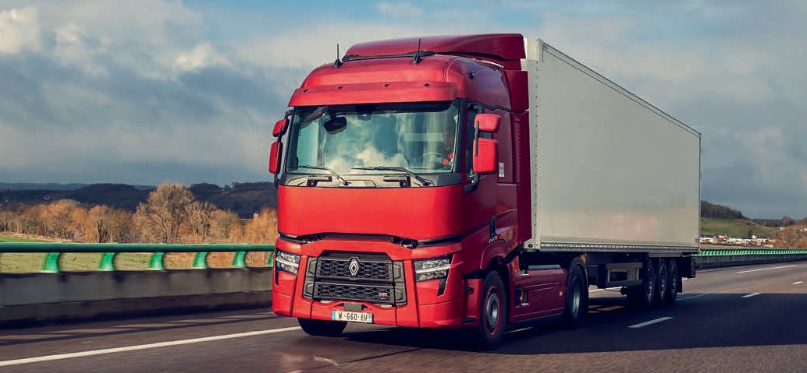

12/2023

renault-trucks.co.uk
We recommend Renault Trucks Oils.
Dimensions and characteristics are only indicative.
The manufacturer reserves the right to modify them without notice. Renault Trucks SAS with a capital of € 50,000,000 - 954 506 077 RCS Non contractual photos
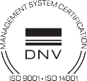
UK







